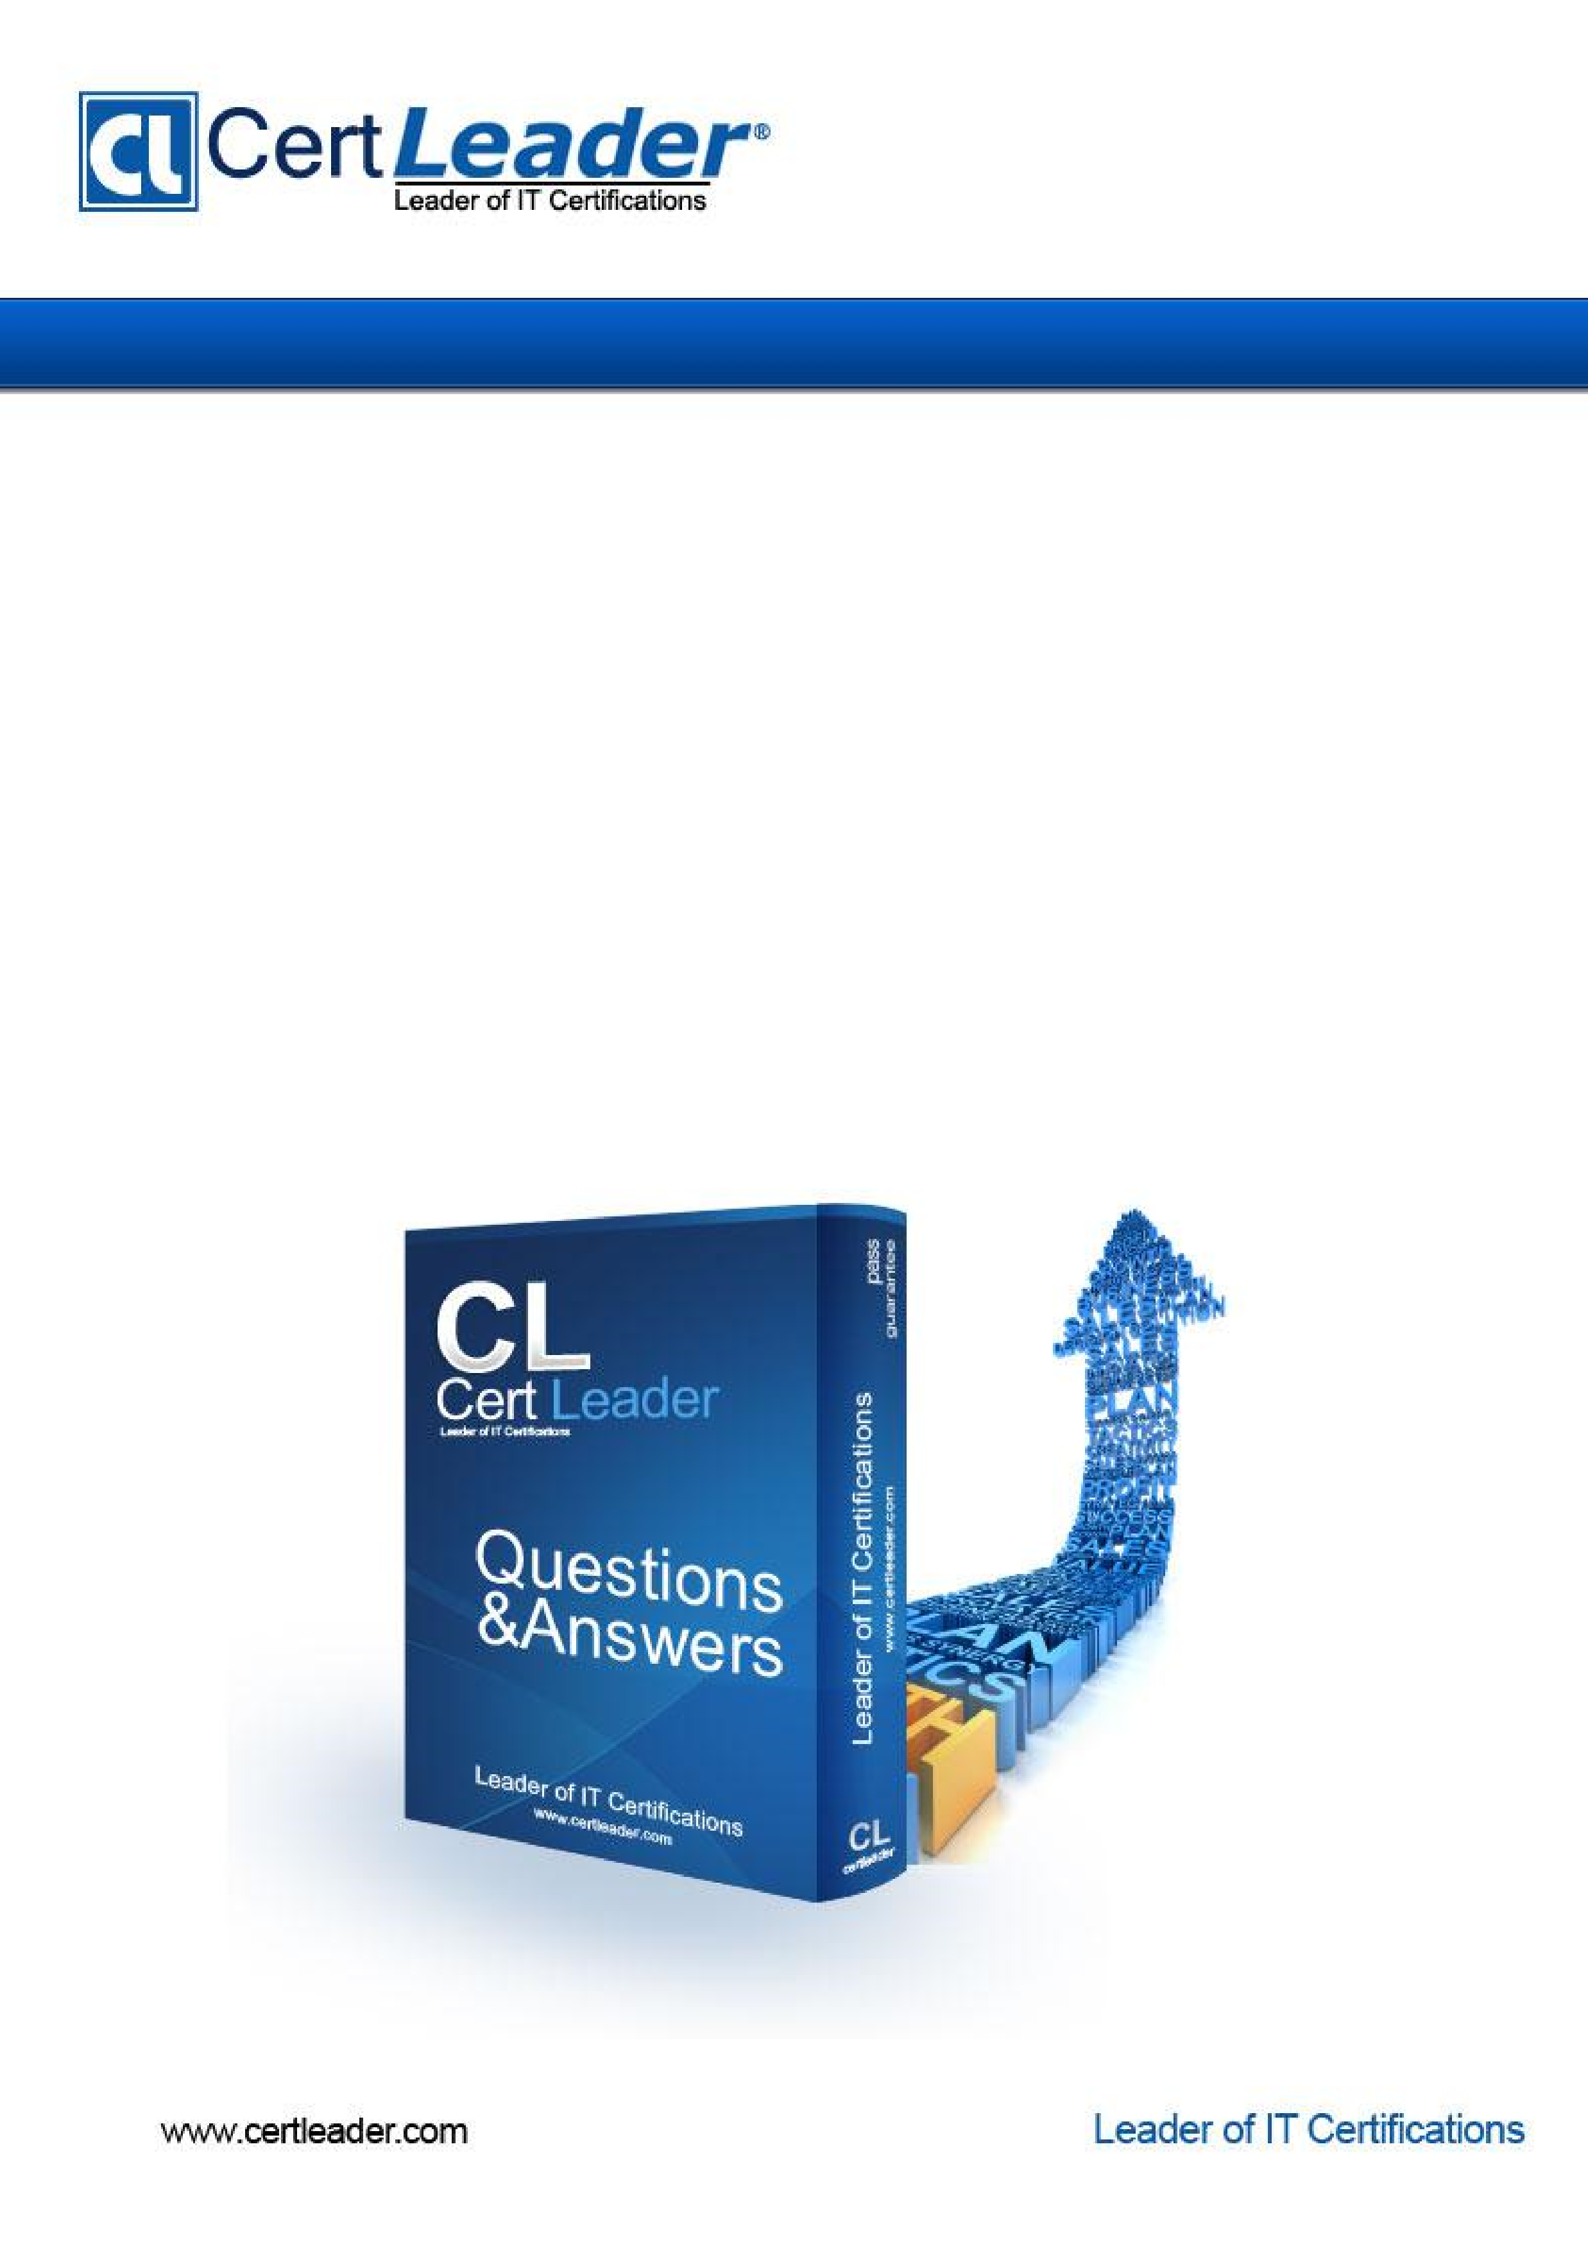

**1Z0-808:**

Java

SE

8

Programmer

I

**Version:**

V

14.0

1. Given:

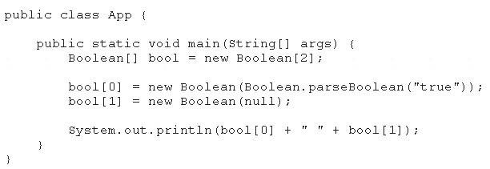

What is the result?

1. True false
2. True null
3. Compilation fails
4. A NullPointerException is thrown at runtime

## Answer: A

2. Which three statements are true about the structure of a Java class? (Choose three.) A. A class cannot have the same name as its field.

1. A public class must have a main method.
2. A class can have final static methods.
3. A class can have overloaded private constructors.
4. Fields need to be initialized before use.
5. Methods and fields are optional components of a class.

## Answer: BDE 🡺 BCE demistik cikti CDF

3. Given the code fragment:

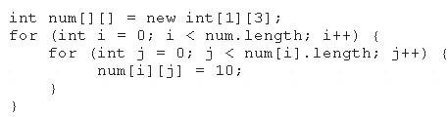

Which option represents the state of the num array after successful completion of the outer loop?

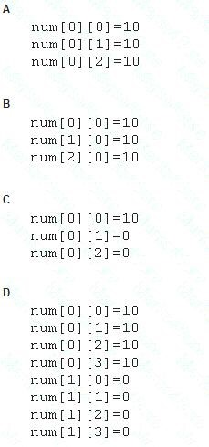

A. Option A

# B. Option B

# C. Option C

# D. Option D

## Answer: A

4. Given the code fragment: farkli sekilde cikti

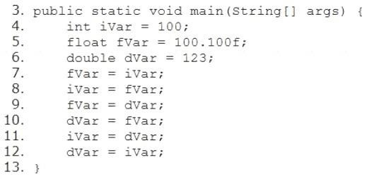

Which three lines fail to compile? (Choose three.)

1. Line 7
2. Line 8
3. Line 9
4. Line 10
5. Line 11
6. Line 12

## Answer: BCE

5. Given:

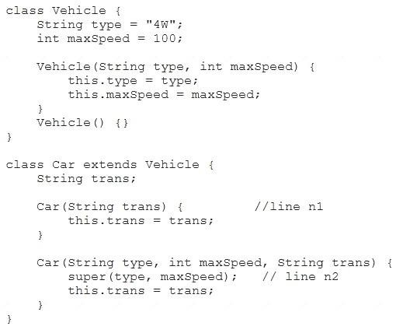

And given the code fragment:

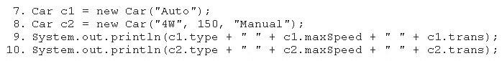

What is the result?

1. 4W 100 Auto4W 150 Manual
2. null 0 Auto4W 150 Manual
3. Compilation fails only at line n1
4. Compilation fails only at line n2
5. Compilation fails at both line n1 and line n2

## Answer: A cikti

6. Given the code fragment:

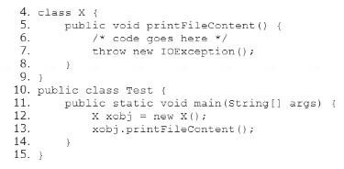

Which two modifications should you make so that the code compiles successfully? (Choose two.)

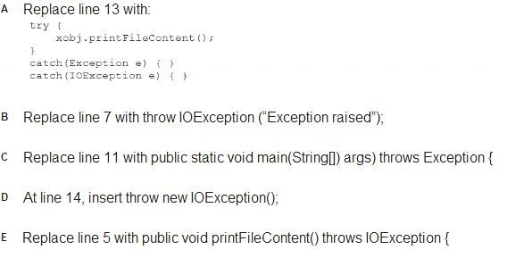

1. Option A
2. Option B
3. Option C
4. Option D

# E. Option E

## Answer: CE

7. Given the code fragments:

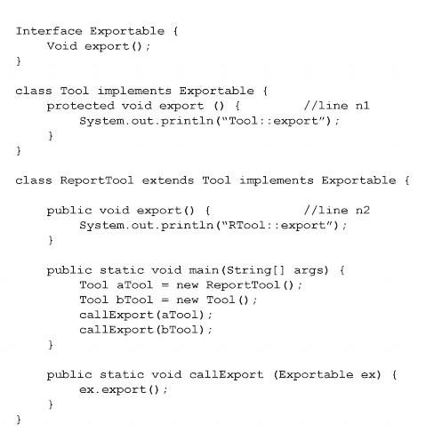

What is the result?

1. Compilation fails only at line n2.
2. RTool::exportTool::export
3. Tool::exportTool:export
4. Compilation fails only at line n1.
5. Compilation fails at both line n1 and line n2.

## Answer: D

8. Given the code fragment:

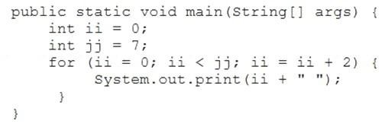

What is the result?

1. 2 4
2. 0 2 4 6
3. 0 2 4
4. Compilation fails.

## Answer: B

Explanation:



9. Given:

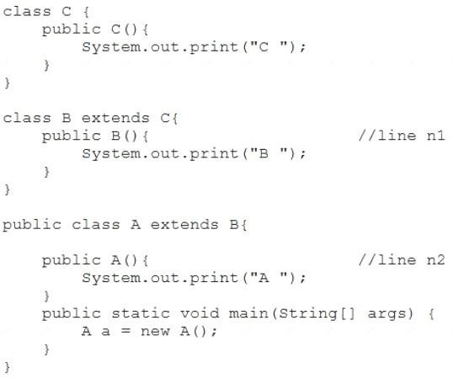

What is the result?

1. C B A
2. C
3. A B C
4. Compilation fails at line n1 and line n2

## Answer: A

10. Given this class:

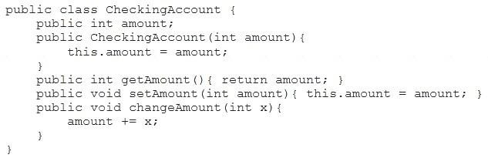

And given this main method, located in another class:

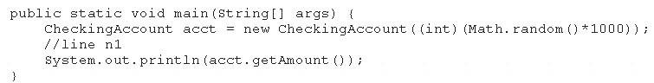

Which three lines, when inserted independently at line n1, cause the program to print a 0 balance?

1. acct.setAmount(-acct.getAmount());
2. acct.amount = 0; <option D earlier>
3. acct.setAmount(0);
4. acct.getAmount() = 0; <option E earlier>
5. this.amount = 0; <option A earlier>
6. acct.changeAmount(0); <option F earlier>
7. acct.changeAmount(-acct.amount); <option G earlier>

## Answer: BCG cikti

11. Given:

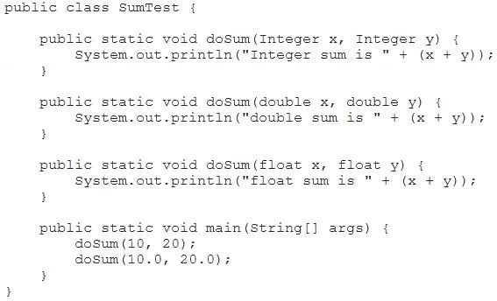

What is the result?

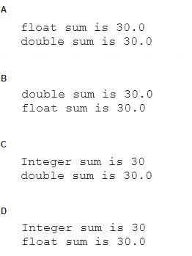

1. Option A
2. Option B
3. Option C
4. Option D

## Answer: A cikti

12. Given:

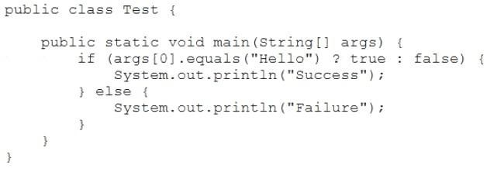

And given the commands:



What is the result?

1. Success
2. Failure
3. Compilation fails.
4. An exception is thrown at runtime

**Answer:** A 13.

Given the code fragment:

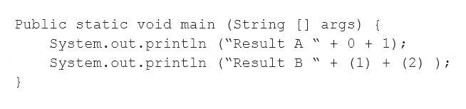

What is the result?

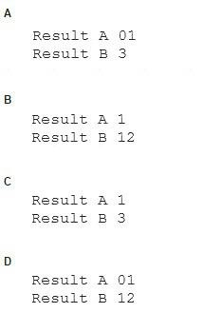

1. Option A
2. Option B
3. Option C
4. Option D

## Answer: D

14. Given:

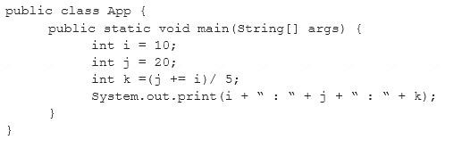

What is the result?

1. 10 : 30 : 6
2. 10 : 22 : 22
3. 10 : 22 : 20
4. 10 : 22 : 6

## Answer: A

15. Given the code fragment:

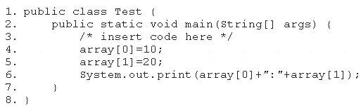

Which code fragment, when inserted at line 3, enables the code to print 10:20?

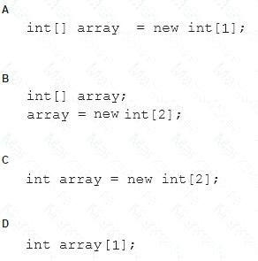

1. Option A
2. Option B
3. Option C
4. Option D

## Answer: B

Explanation:

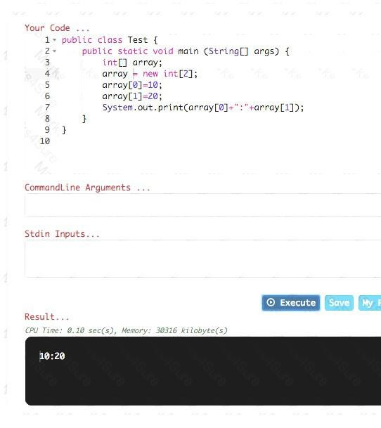

16. Given the code fragment:

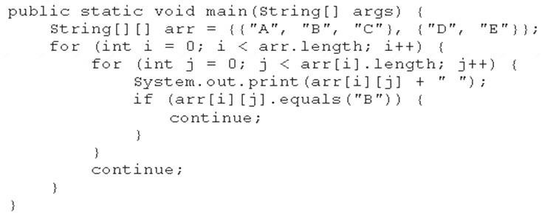

What is the result?

1. A B C
2. A B C D E
3. A B D E
4. Compilation fails.

## Answer: B cikti

17. Given the code fragment:

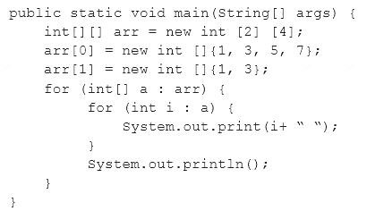

What is the result?

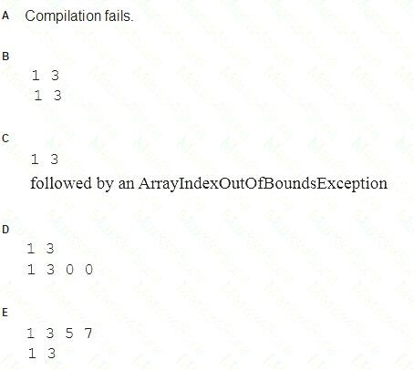

1. Option A
2. Option B
3. Option C
4. Option D E. Option E

## Answer: E cikti

Explanation:

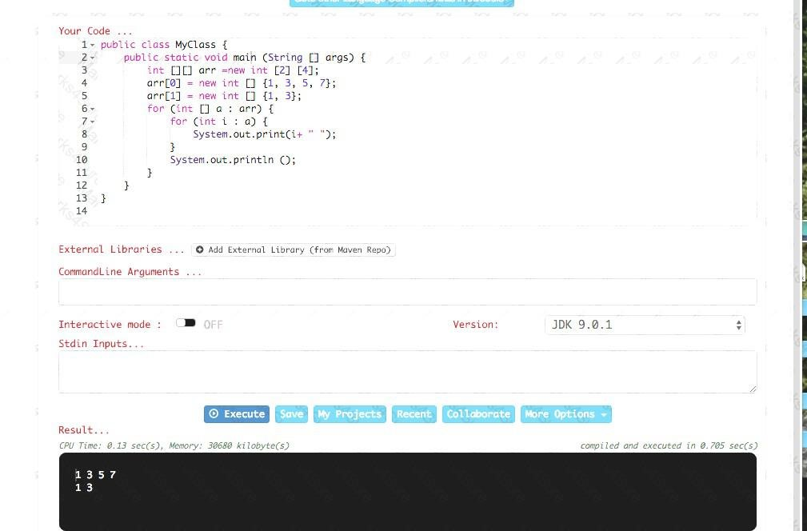

18. Given:

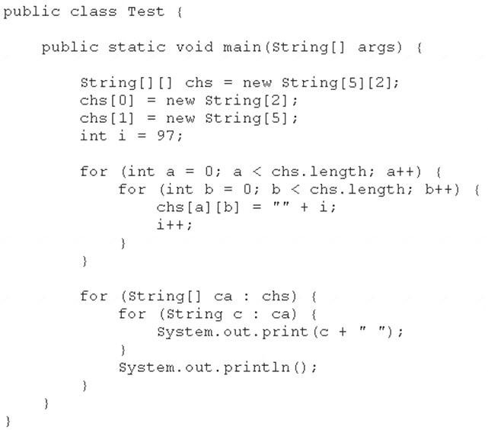

What is the result?

A. 97 98 99 100 null null null B. 97 98 99 100 101 102 103

1. Compilation fails.
2. A NullPointerException is thrown at runtime.
3. An ArraylndexOutOfBoundsException is thrown at runtime.

## Answer: E cikti

Explanation:

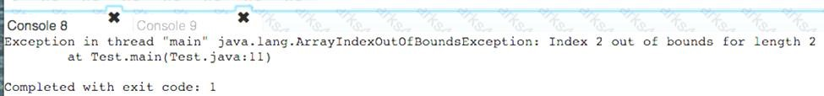

19. Given: Acc.java:

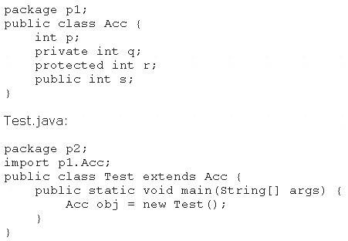

Which statement is true?

1. Both p and s are accessible via obj.
2. Only s is accessible via obj.
3. Both r and s are accessible via obj.
4. p, r, and s are accessible via obj.

## Answer: B

20. Given the code fragment from three files:

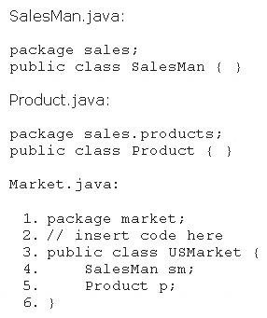

Which code fragment, when inserted at line 2, enables the code to compile?

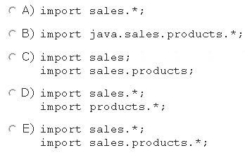

1. Option A
2. Option B
3. Option C
4. Option D
5. Option E

## Answer: E

21. Given the code fragment:

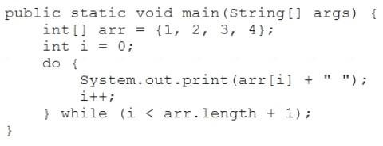

What is the result?

1. 1 2 3 4followed by an ArrayIndexOutOfBoundsException
2. 1 2 3
3. 1 2 3 4
4. Compilation fails.

## Answer: A

Explanation:

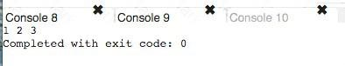

22. Which three statements are true about the structure of a Java class? (Choose three.) A. A public class must have a main method.

1. A class can have only one private constructors.
2. A method can have the same name as a field.
3. A class can have overloaded static methods.
4. The methods are mandatory components of a class.
5. The fields need not be initialized before use.

## Answer: ACF cikti ama biz CDF

23. Given the code fragment:

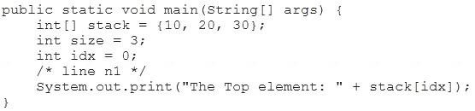

Which code fragment, inserted at line n1, prints The Top element: 30?

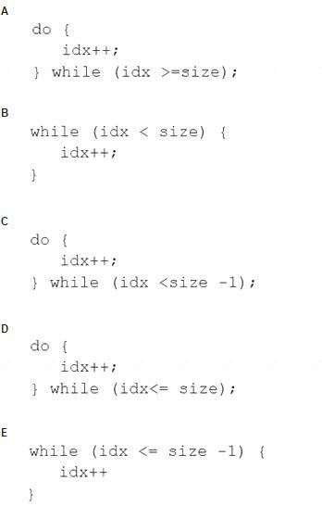

1. Option A
2. Option B
3. Option C
4. Option D E. Option E

## Answer: C cikti 2 optionli olarak

24. Given the code fragment:

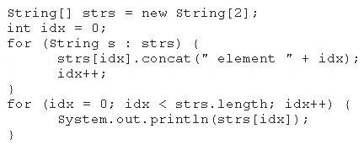

What is the result?

1. Element 0Element 1
2. Null element 0Null element 1
3. NullNull
4. A NullPointerException is thrown at runtime.

## Answer: D cikti

25. Given:

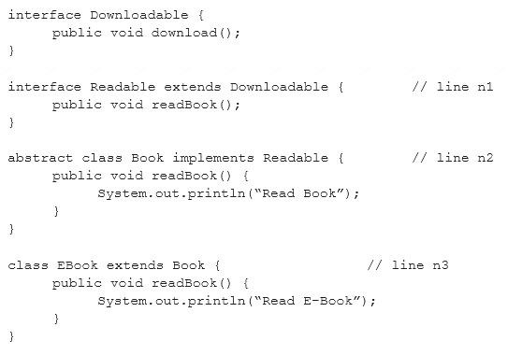

And given the code fragment:



What is the result?

1. Compilation fails at line n2.
2. Read Book
3. Read E-Book D. Compilation fails at line n1.

E. Compilation fails at line n3.

## Answer: E

26. Given:

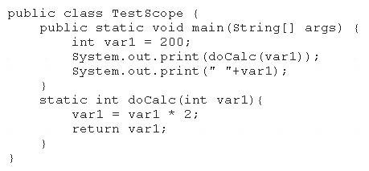

What is the result?

1. 400 200
2. 200 200
3. 400 400

D. Compilation fails.

## Answer: A

27. Given:

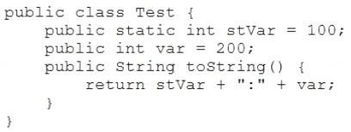

And given the code fragment:

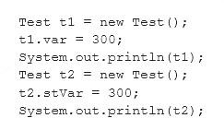

What is the result?

1. 300:300200:300
2. 300:100200:300
3. 300:00:300
4. 100:300300:200

## Answer: D

28. Given the code fragment:



And given the requirements:

1. Process all the elements of the array in the order of entry.
2. Process all the elements of the array in the reverse order of entry.
3. Process alternating elements of the array in the order of entry.

Which two statements are true? (Choose two.)

1. Requirements 1, 2, and 3 can be implemented by using the enhanced for loop.
2. Requirements 1, 2, and 3 can be implemented by using the standard for loop.
3. Requirements 2 and 3 CANNOT be implemented by using the standard for loop.
4. Requirement 1 can be implemented by using the enhanced for loop.
5. Requirement 3 CANNOT be implemented by using either the enhanced for loop or the standard for loop.

## Answer: BD cikti

29. Given the code fragment:

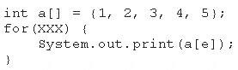

Which option can replace xxx to enable the code to print 135?

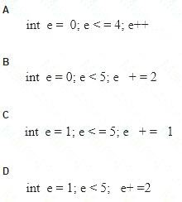

1. Option A
2. Option B
3. Option C
4. Option D

## Answer: B

30. Given:

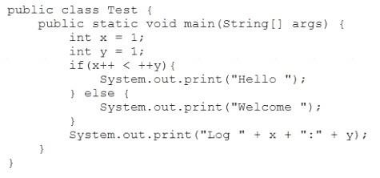

What is the result?

1. Hello Log 2:2
2. Welcome Log 1:2
3. Welcome Log 2:1
4. Hello Log 1:2

## Answer: A

Explanation:

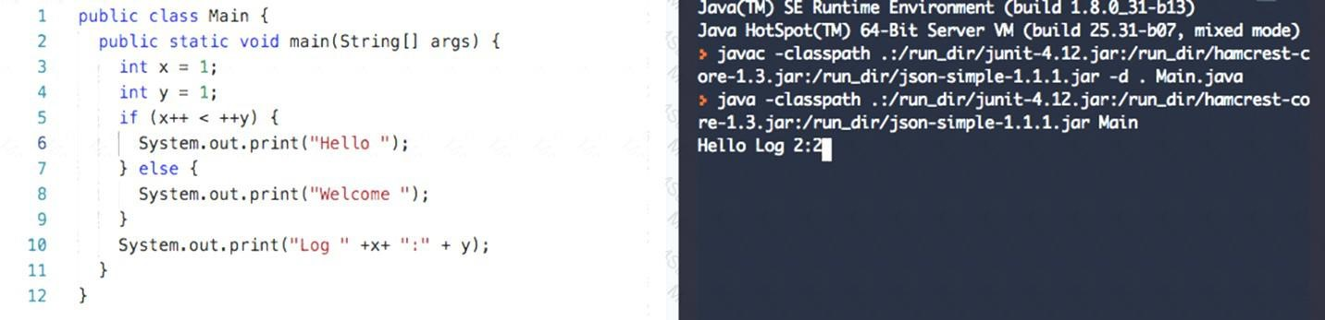

31. Given:

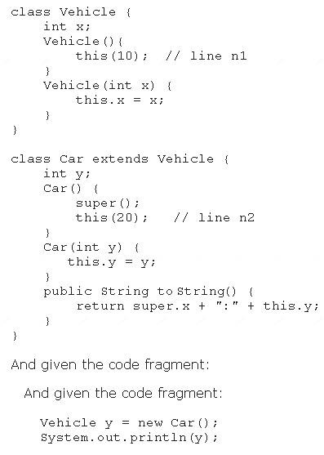

What is the result?

1. 10:20
2. 0:20
3. Compilation fails at line n1
4. Compilation fails at line n2

**Answer:** D cikti

32. Given the code fragment:

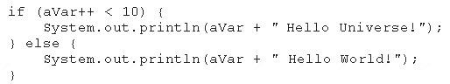

What is the result if the integer aVar is 9? A. Compilation fails.

1. 10 Hello Universe!
2. 10 Hello World!
3. 9 Hello World!

## Answer: B

33. Given the code fragment:

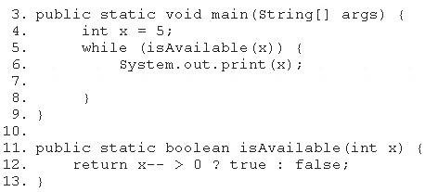

Which modification enables the code to print 54321?

1. Replace line 6 with System.out. print (--x) ;
2. At line 7, insert x --;
3. Replace line 6 with --x; and, at line 7, insert System.out.print (x);
4. Replace line 12 with return (x > 0) ? false: true;

## Answer: B cikti

34. Given:

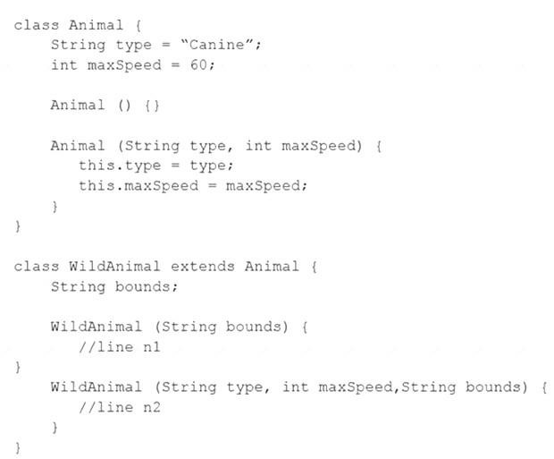

And given the code fragment:

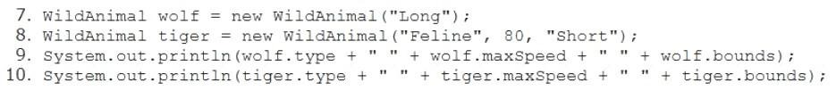

and this output:

Canine 60 Long

Feline 80 Short

Which two modifications enable the code to print this output? (Choose two.)

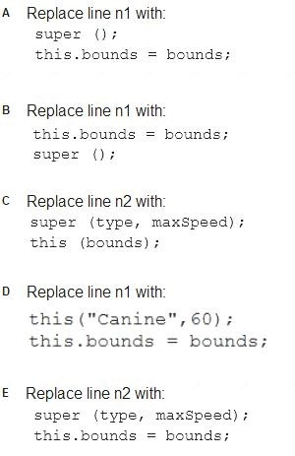

1. Option A
2. Option B
3. Option C
4. Option D
5. Option E

## Answer: AE

35. Given the code fragment:

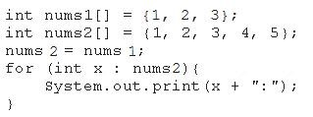

What is the result? A. 1:2:3:4:5:

1. 1:2:3:
2. Compilation fails.
3. An ArrayOutOfBoundsException is thrown at runtime.

## Answer: B

36. Given the code fragment:

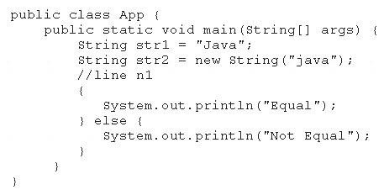

Which code fragment, when inserted at line n1, enables the App class to print Equal?

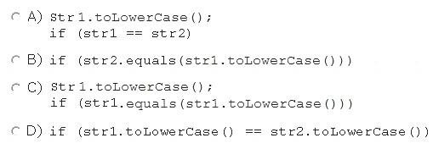

1. Option A
2. Option B
3. Option C
4. Option D

## Answer: B cikti

37. Given the following code:

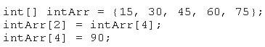

What are the values of each element in intArr after this code has executed?

1. 15, 60, 45, 90, 75
2. 15, 90, 45, 90, 75
3. 15, 30, 75, 60, 90
4. 15, 30, 90, 60, 90
5. 15, 4, 45, 60, 90

## Answer: C cikit

38. Given the code fragment:



And given the requirements:

1. Process all the elements of the array in the reverse order of entry.
2. Process all the elements of the array in the order of entry.
3. Process alternating elements of the array in the order of entry.

Which two statements are true? (Choose two.)

1. Requirements 1, 2, and 3 can be implemented by using the enhanced for loop.
2. Requirements 1, 2, and 3 can be implemented by using the standard for loop.
3. Requirements 2 and 3 CANNOT be implemented by using the standard for loop.
4. Requirement 2 can be implemented by using the enhanced for loop.
5. Requirement 3 CANNOT be implemented by using either the enhanced for loop or the standard for loop.

## Answer: BD cikti

39. Given the code fragment:

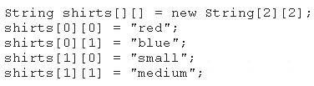

Which code fragment prints red: blue: small: medium?

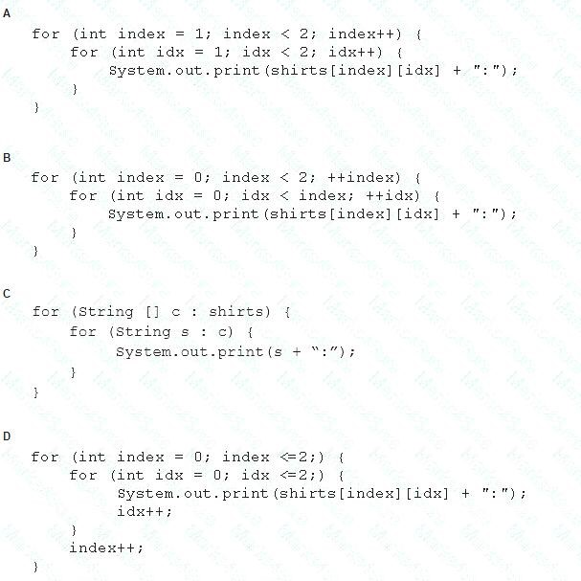

1. Option A
2. Option B
3. Option C
4. Option D

## Answer: C

40. Given the code fragment:

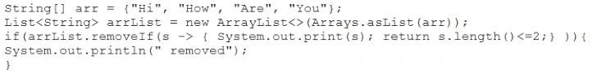

What is the result?

1. Compilation fails.
2. The program compiles, but it prints nothing.
3. HiHowAreYou removed
4. An UnsupportedOperationException is thrown at runtime.

## Answer: C

Explanation:

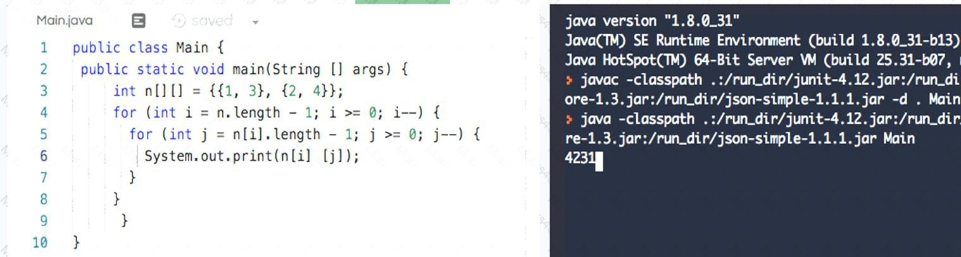

41. Given the code fragment:

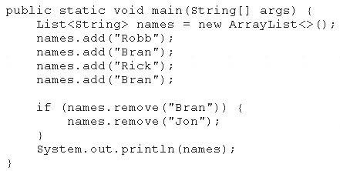

What is the result?

1. [Robb, Rick, Bran]
2. [Robb, Rick]
3. [Robb, Bran, Rick, Bran]
4. An exception is thrown at runtime.

## Answer: A

42. Given:

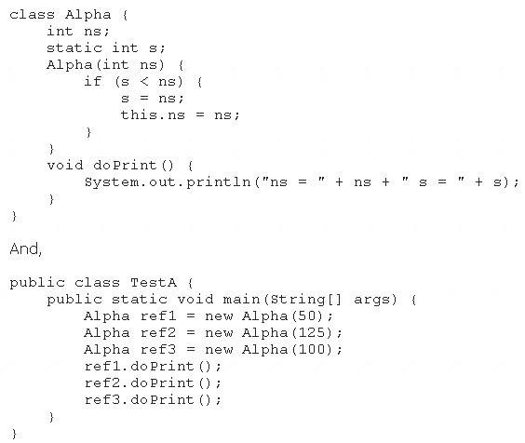

What is the result?

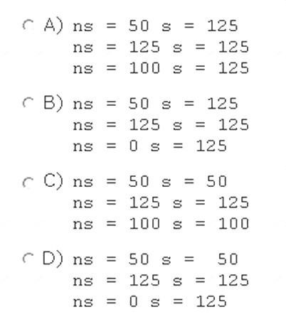

1. Option A
2. Option B
3. Option C
4. Option D

**Answer:** B

43. Given the code fragment:

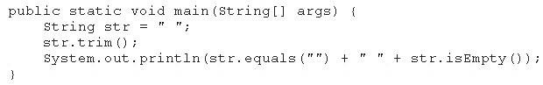

What is the result?

1. true true
2. true false
3. false false
4. false true

## Answer: C

44. Given the code snippet from a compiled Java source file:

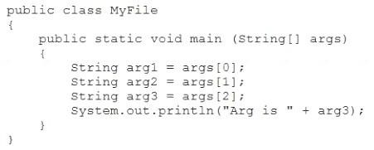

and this output:



Which command should you run to obtain this output?

1. java MyFile 2
2. java MyFile 1 2 3 4
3. java MyFile 1 2 2
4. java MyFile 2 2

## Answer: C

45. Given the code fragment:

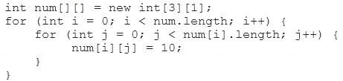

Which option represents the state of the num array after successful completion of the outer loop?

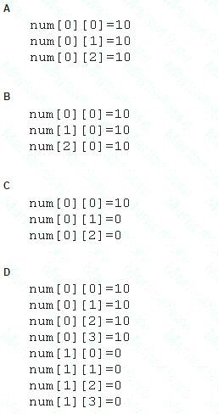

1. Option A
2. Option B
3. Option C
4. Option D

## Answer: B

46. Given the code fragment:

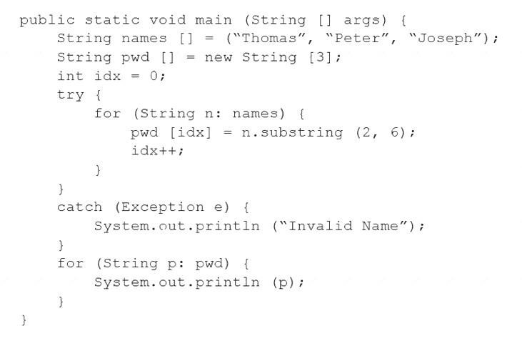

What is the result?

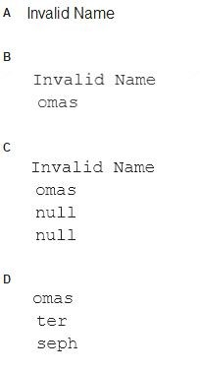

1. Option A
2. Option B
3. Option C
4. Option D

**Answer:** C cikti

47. Given the code fragment:

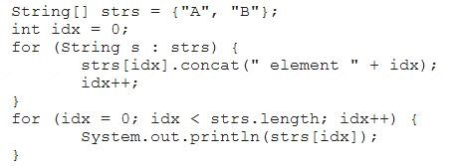

What is the result?

1. AB
2. A element 0B element 1
3. A NullPointerException is thrown at runtime.
4. A 0B 1

**Answer:** A

48. Given the code fragment:

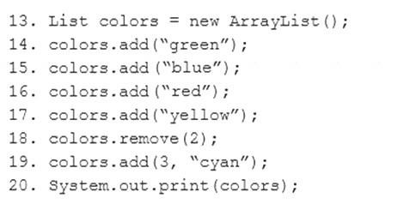

What is the result?

1. [green, red, yellow, cyan]
2. [green, blue, yellow, cyan]
3. [green, red, cyan, yellow]
4. An IndexOutOfBoundsException is thrown at runtime.

## Answer: B

49. Given the code fragment:

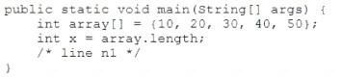

Which two code fragments can be independently inserted at line n1 to enable the code to print the elements of the array in reverse order? (Choose two.)

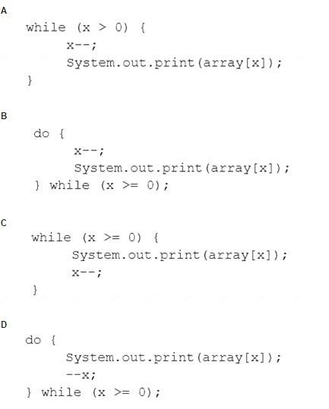

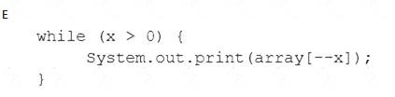

1. Option A
2. Option B
3. Option C
4. Option D
5. Option E

## Answer: AE

50. Which statement will empty the contents of a StringBuilder variable named sb?

1. sb. deleteAll ();
2. sb. delete (0, sb. size () );
3. sb. delete (0, sb. length () );
4. sb. removeAll ();

## Answer: C cikti

51. Which three statements describe the object-oriented features of the Java language? (Choose three.) A. Objects cannot be reused.

1. A subclass must override the methods from a superclass.
2. Objects can share behaviors with other objects.
3. A package must contain a main class.
4. Object is the root class of all other objects.
5. A main method must be declared in every class.

## Answer: BCE cikti

52. Given:

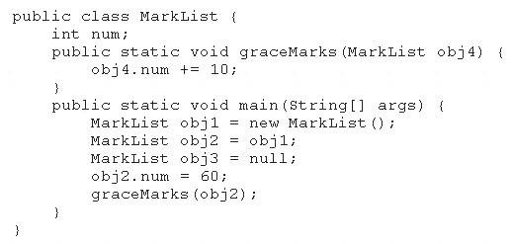

How many MarkList instances are created in memory at runtime?

1. 1
2. 2
3. 3
4. 4

## Answer: A

53. Given the code fragment:

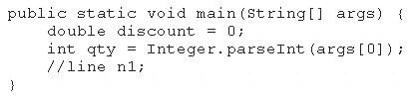

And given the requirements:

If the value of the qty variable is greater than or equal to 90, discount = 0.5 If the value of the qty variable is between 80 and 90, discount = 0.2

Which two code fragments can be independently placed at line n1 to meet the requirements? (Choose two.)

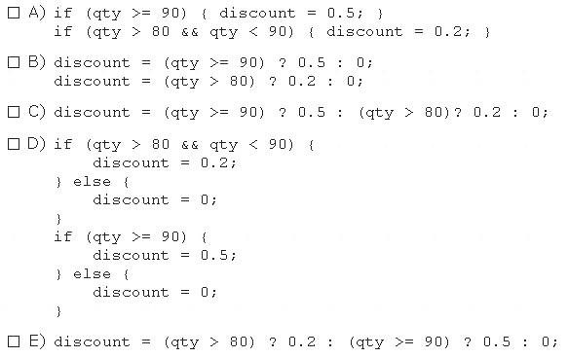

1. Option A
2. Option B
3. Option C
4. Option D
5. Option E

## Answer: AC cikti

54. Given the code fragment:

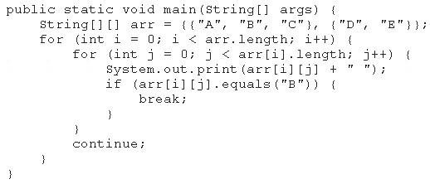

What is the result?

1. A B C
2. A B C D E
3. A B D E
4. Compilation fails.

## Answer: C

55. Given the code fragment:

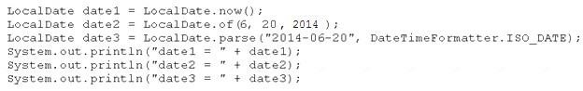

Assume that the system date is June 20, 2014. What is the result?

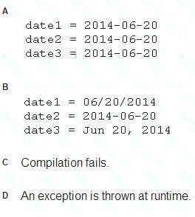

1. Option A
2. Option B
3. Option C
4. Option D

## Answer: D cikti

56. Given the code fragment:

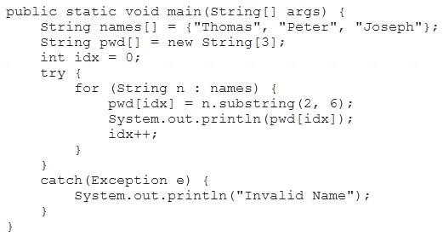

What is the result?

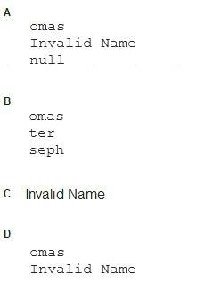

1. Option A
2. Option B
3. Option C
4. Option D

## Answer: D cikti

Explanation:

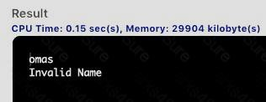

57. Given the definitions of the MyString class and the Test class:

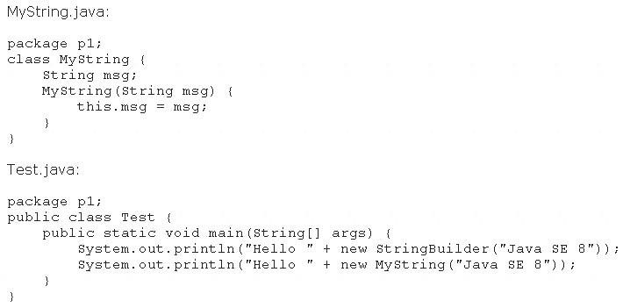

What is the result?

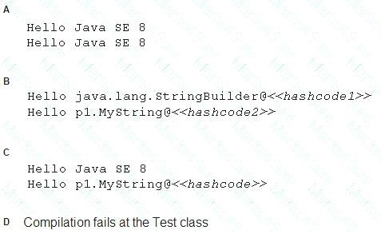

1. Option
2. Option B
3. Option C
4. Option D

## Answer: C cikti

58. Given:

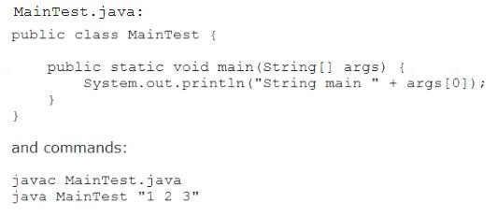

What is the result?

1. String main 1
2. An exception is thrown at runtime
3. String main 1 2 3
4. String main 123

## Answer: C cikti

59. Given this array:



Which two code fragments, independently, print each element in this array? (Choose two.)

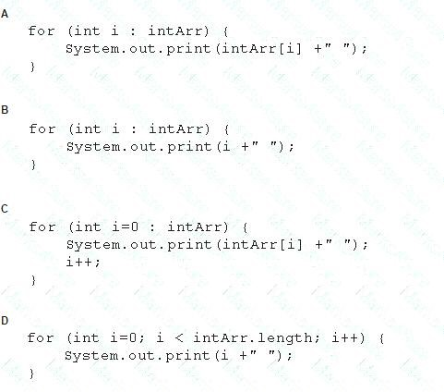

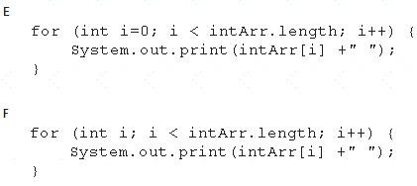

A. Option A

B. Option B

C. Option C

D. Option D

E. Option E

F. Option**Answer:** BE cikti F

60. Given:

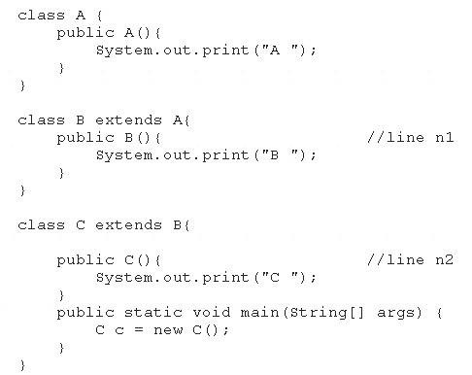

What is the result?

1. C B A
2. C
3. A B C
4. Compilation fails at line n1 and line n2

**Answer:** C cikti

61. Given the following code:

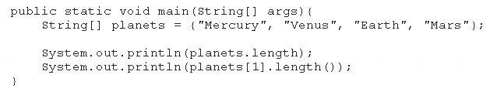

What is the output?

1. 44
2. 35
3. 47
4. 54
5. 45
6. 421

**Answer:** E

62. Given the code fragment:

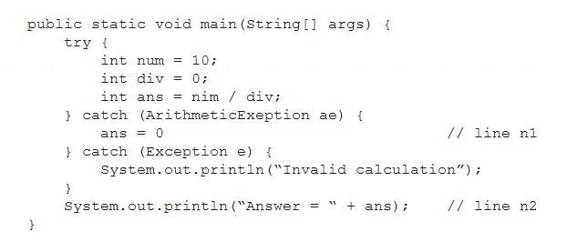

What is the result?

1. Answer = 0
2. Invalid calculation
3. Compilation fails only at line n1.
4. Compilation fails only at line n2.
5. Compilation fails at line n1 and line2.

## Answer: E cikti diger version

63. Given:

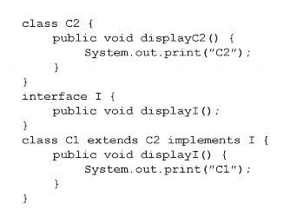

And given the code fragment:

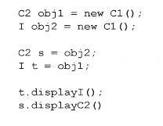

What is the result?

1. C2C2
2. C1C2
3. C1C1
4. Compilation fails

## Answer: D

64. Given the code fragment:

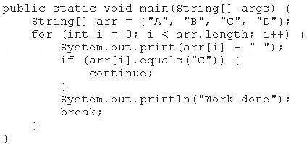

What is the result?

1. A B C Work done
2. A B C D Work done
3. A Work done
4. Compilation fails

## Answer: C cikti

65. You are developing a banking module. You have developed a class named ccMask that has a maskcc method. Given the code fragment:

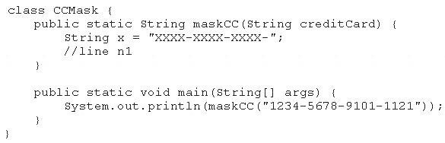

You must ensure that the maskcc method returns a string that hides all digits of the credit card number except the four last digits (and the hyphens that separate each group of four digits).

Which two code fragments should you use at line n1, independently, to achieve this requirement? (Choose

two.)

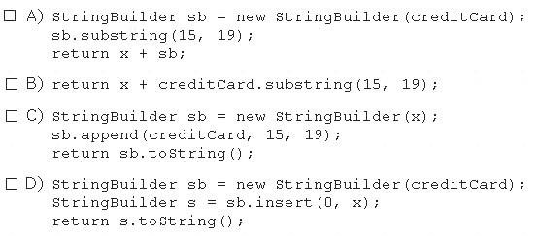

1. Option A
2. Option B
3. Option C
4. Option D

**Answer:** BC

66. Given the codefragment:

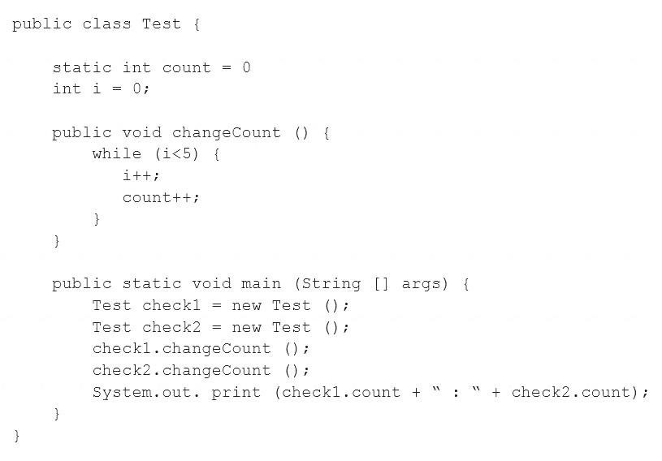

What is the result?

1. 5 : 5
2. 10 : 10
3. 5 : 10
4. Compilation fails.

## Answer: B

67. Which two statements are true? (Choose two.)

1. Error class is unextendable.
2. Error class is extendable.
3. Error is a RuntimeException.
4. Error is an Exception.
5. Error is a Throwable.

## Answer: BE cikti

68. Given:

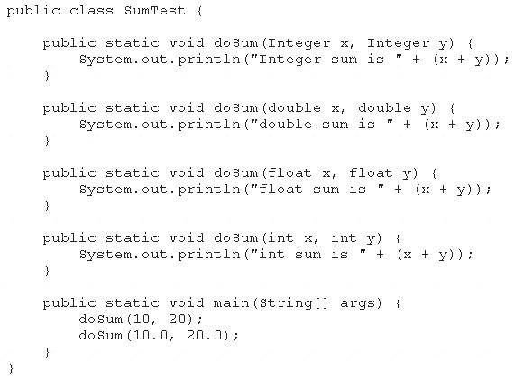

What is the result?

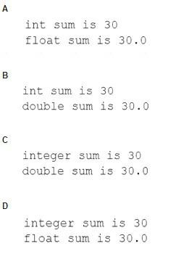

1. Option A
2. Option B
3. Option C
4. Option D

## Answer: B

69. Given the code fragment:

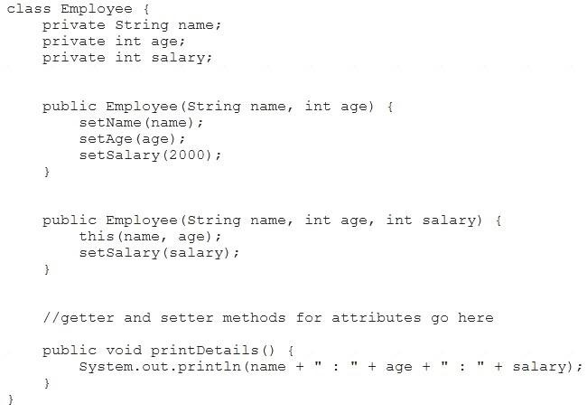

Test.java:

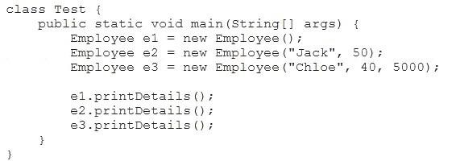

Which is the result?

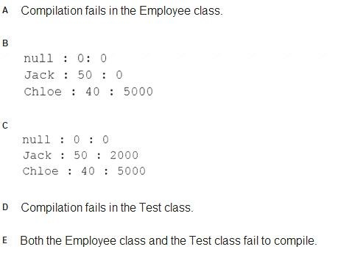

1. Option A
2. Option B
3. Option C
4. Option D
5. Option E

## Answer: D cikti

70. Given the code fragment:



Which code fragment, when inserted at line n1, enables the App class to print Equal?

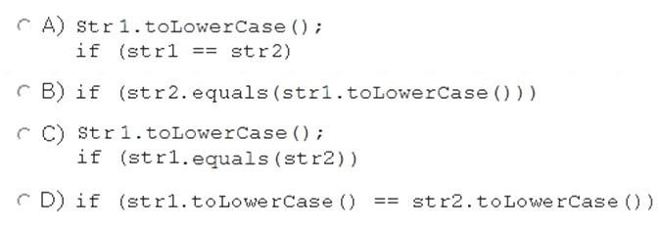

1. Option A
2. Option B
3. Option C
4. Option D

**Answer:** B cikti

71. Given the code fragment:

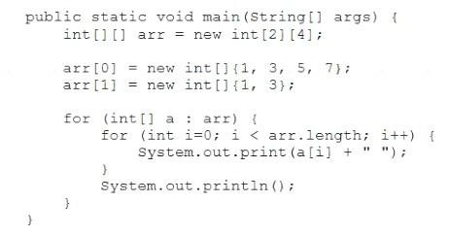

What is the result?

A. 1 3 5 71 3 B. 1 31 3

1. 1 31 3 0 0
2. 1 3followed by an ArrayIndexOutOfBoundsException
3. Compilation fails.

## Answer: B cikti

Explanation:

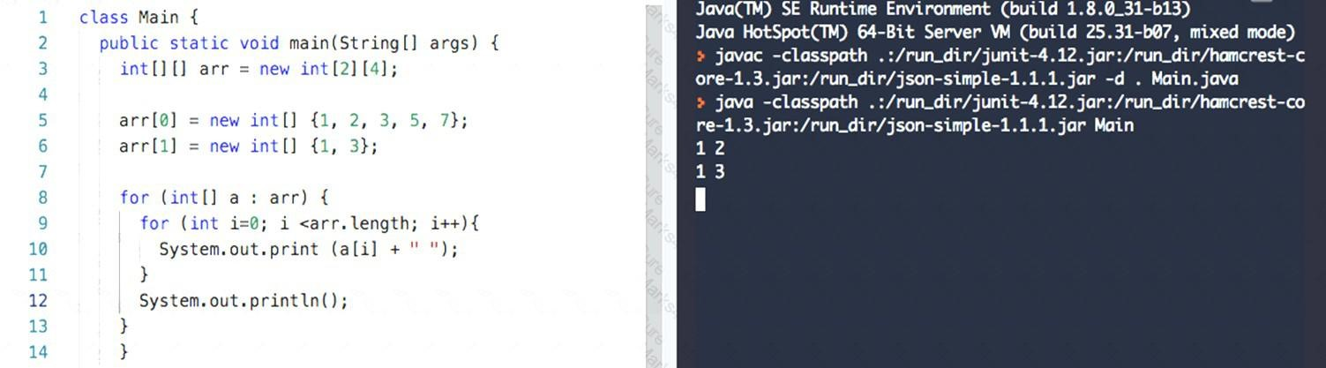

72. Given:

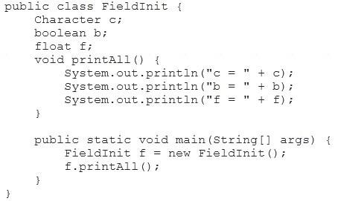

What is the result?

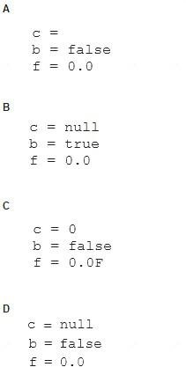

1. Option A
2. Option B
3. Option C
4. Option D

## Answer: D cikti

Explanation:

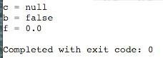

73. Given:

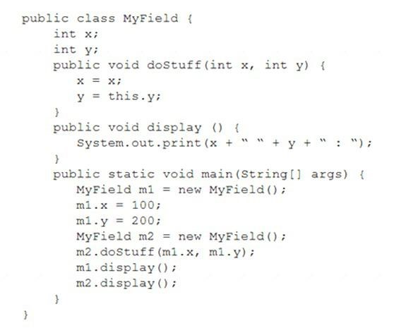

What is the result? A. 100 200 : 0 0 :

1. 100 200 : 100 0 :
2. 100 200 : 100 200 :
3. 0 0 : 100 0 :

## Answer: A

74. Which statement best describes encapsulation?

1. Encapsulation ensures that classes can be designed so that only certain fields and methods of an object are accessible from other objects.
2. Encapsulation ensures that classes can be designed so that their methods are inheritable.
3. Encapsulation ensures that classes can be designed with some fields and methods declared as abstract.
4. D. Encapsulation ensures that classes can be designed so that if a method has an argument MyType x, any subclass of MyType can be passed to that method.

## Answer: A cikti

75. Given:

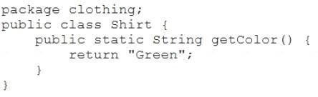

Given the code fragment:

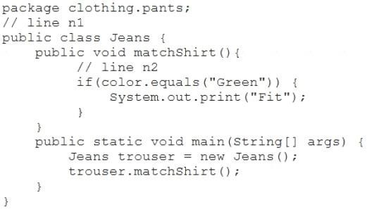

Which two sets of actions, independently, enable the code fragment to print Fit?

1. At line n1 insert: import clothing.Shirt;At line n2 insert: String color = Shirt.getColor();
2. At line n1 insert: import clothing;At line n2 insert: String color = Shirt.getColor();
3. At line n1 insert: import static clothing.Shirt.getColor;At line n2 insert: String color = getColor();
4. At line n1 no changes required.At line n2 insert: String color = Shirt.getColor();
5. At line n1 insert: import Shirt;At line n2 insert: String color = Shirt.getColor();

## Answer: AC

77. Given the code fragment:

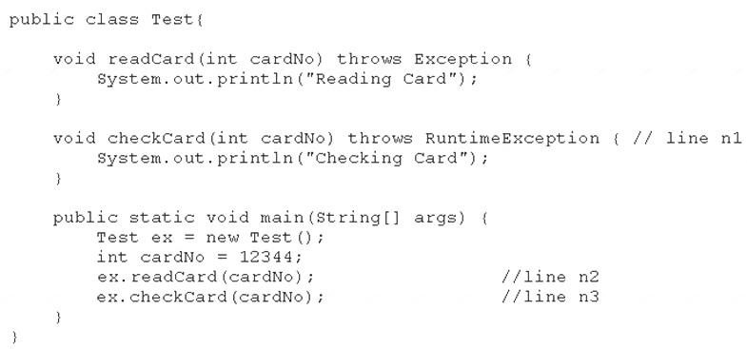

What is the result?

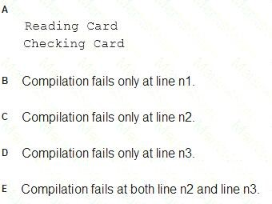

1. Option A
2. Option B
3. Option C
4. Option D
5. Option E

**Answer:** C

78. Given the code fragment:

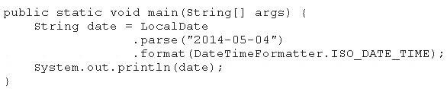

What is the result?

1. May 04, 2014T00:00:00.000
2. 2014-05-04T00:00: 00.000
3. 5/4/14T00:00:00.000
4. An exception is thrown at runtime.

**Answer:** D

79. Given the code fragment:

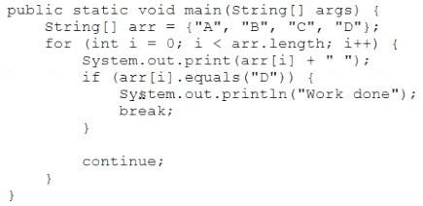

What is the result?

1. A B C Work done
2. A B C D Work done
3. A Work done
4. Compilation fails

## Answer: B cikti

Explanation:

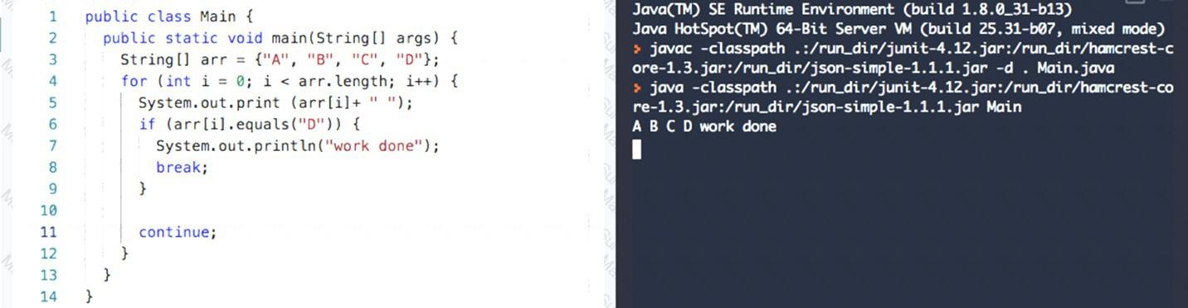

80. Given the code fragment:

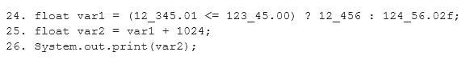

What is the result?

1. An exception is thrown at runtime.
2. Compilation fails.
3. 13480.0
4. 13480.02

## Answer: D

81. Given:

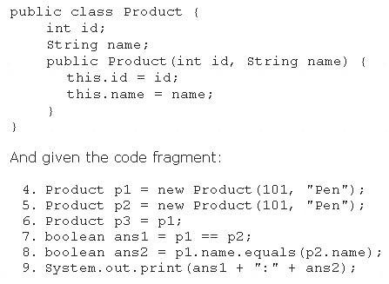

What is the result?

1. true:true
2. true:false
3. false:true
4. false:false

## Answer: C

82. Given:

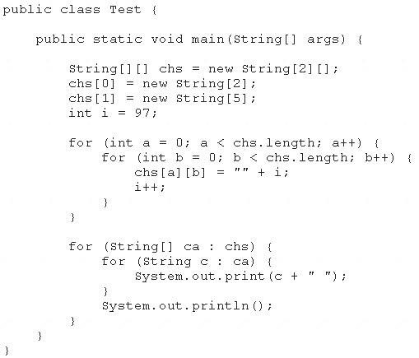

What is the result?

A. 97 98 99 100 null null null B. 97 98 99 100 101 102 103

1. Compilation fails.
2. A NullPointerException is thrown at runtime.
3. An ArraylndexOutOfBoundsException is thrown at runtime.

## Answer: A cikti

83. Given the code fragments:

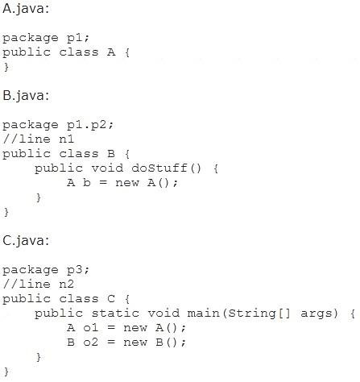

Which modification enables the code to compile?

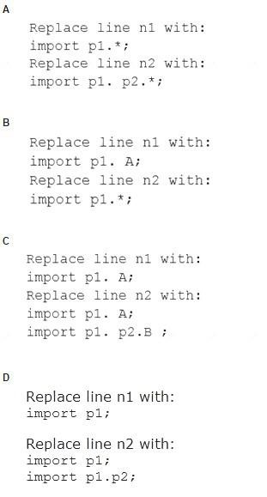

1. Option A
2. Option B
3. Option C
4. Option D

## Answer: C

84. Given the code fragment:

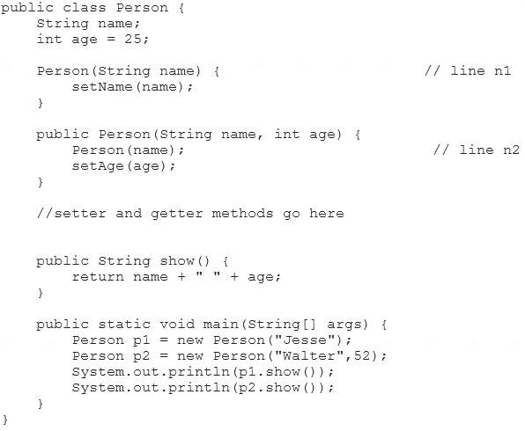

What is the result?

1. Compilation fails at both line n1 and line n2.
2. Compilation fails only at line n2.
3. Compilation fails only at line n1.
4. Jesse 25Walter 52

## Answer: B cikti

85. Given this code for the classes MyException and Test:

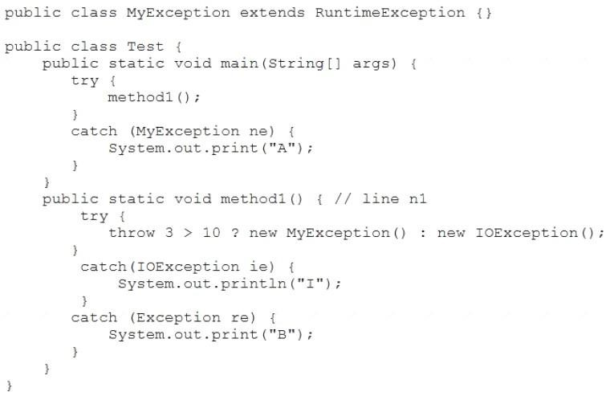

What is the result?

1. A
2. AB
3. A compile time error occurs at line n1.
4. B
5. I

## Answer: E

Explanation:

86. Given:

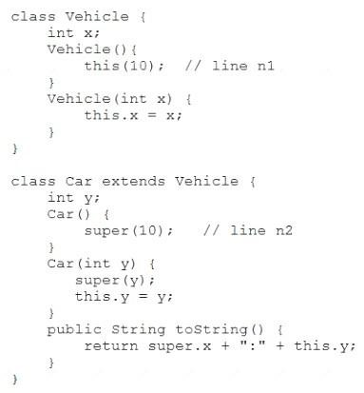

And given the code fragment:



What is the result?

1. Compilation fails at line n2.
2. Compilation fails at line n1.
3. 20:20
4. 10:20

## Answer: C cikti

87. Given the code fragment:

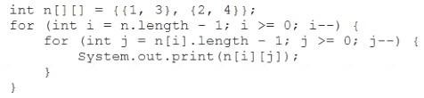

What is the result?

1. 3142
2. 2413
3. 1324
4. 4231

## Answer: D

Explanation:

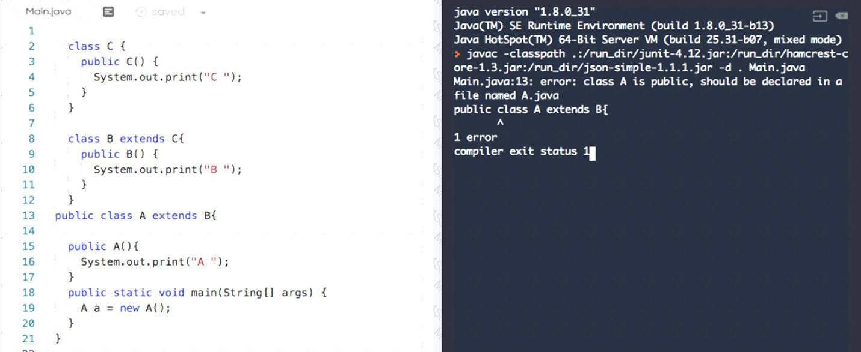

88. Given the code fragment:

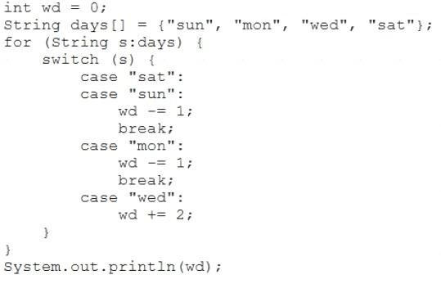

What is the result?

1. 3
2. 0
3. Compilation fails.
4. -1

## Answer: D

89. Given the code fragment:

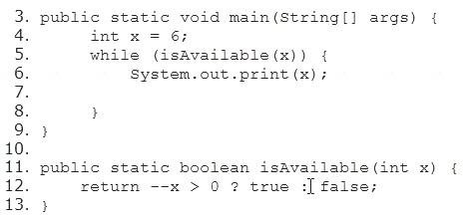

Which modification enables the code to print 54321?

1. Replace line 6 with System.out.print (--x);
2. At line 7, insert x --;
3. Replace line 5 with while (is Available(--x)) {
4. Replace line 12 with return (x > 0) ? false : true;

## Answer: A cikti

90. Given the following code for the classes MyException and Test:

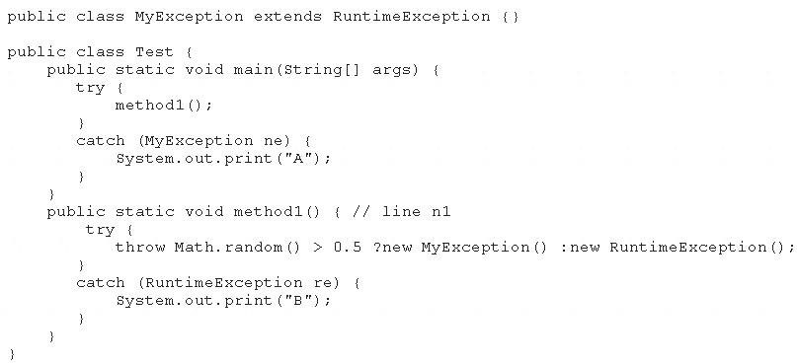

What is the result?

1. A
2. B
3. Either A or B
4. A B
5. A compile time error occurs at line n1

**Answer:** B

91. Given the code fragment:

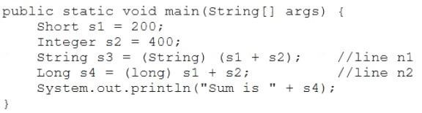

What is the result?

1. Sum is 600
2. Compilation fails at line n1.

C. Compilation fails at line n2.

1. A ClassCastException is thrown at line n1.
2. A ClassCastException is thrown at line n2.

## Answer: B

92. Which statement is true about the switch statement? A. It must contain the default section.

1. The break statement, at the end of each case block, is optional.
2. Its case label literals can be changed at runtime.
3. Its expression must evaluate to a collection of values.

## Answer: B

93. Given:

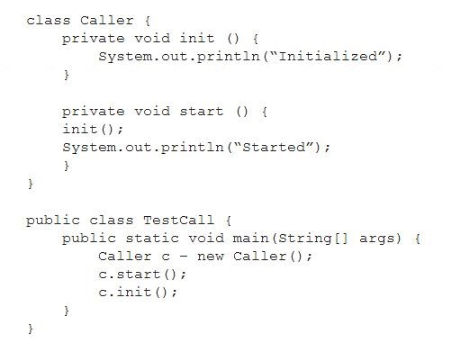

What is the result?

1. An exception is thrown at runtime.
2. InitializedStartedInitialized
3. InitializedStarted
4. Compilation fails.

## Answer: D

94. Given:

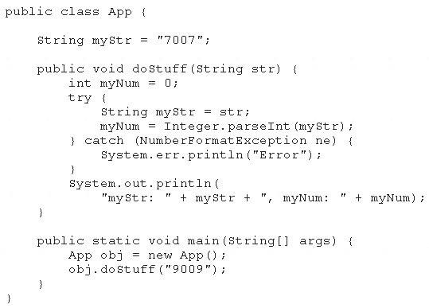

What is the result?

1. myStr: 9009, myNum: 9009
2. myStr: 7007, myNum: 7007
3. myStr: 7007, myNum: 9009
4. Compilation fails

## Answer: C cikti

95. Given:

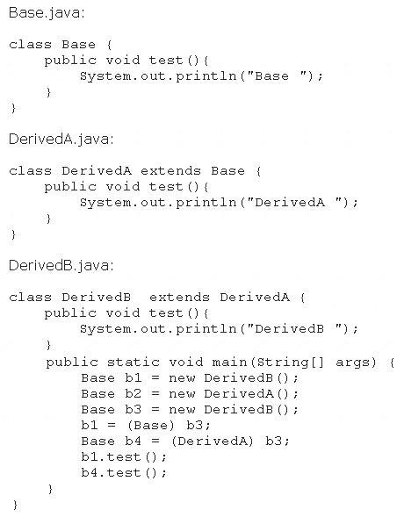

What is the result?

1. BaseDerivedA
2. BaseDerivedB
3. DerivedBDerivedB
4. DerivedBDerivedA
5. A ClassCastException is thrown at runtime.

## Answer: C cikti

96. Given the code fragments:

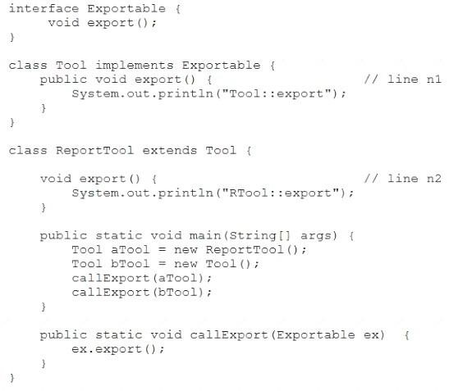

What is the result?

1. Compilation fails only at line n1.
2. Compilation fails only at line n2.
3. Tool::exportTool::export
4. Compilation fails at both line n1 and line2.
5. RTool::exportTool::export

## Answer: B

97. Given this class:

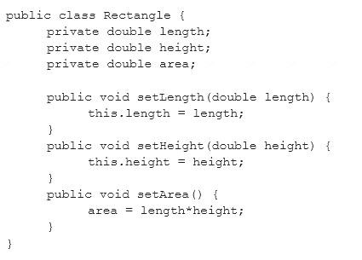

Which two changes would encapsulate this class and ensure that the area field is always equal to length * height whenever the Rectangle class is used?

1. Call the setArea method at the end of the setHeight method.
2. Call the setArea method at the beginning of the setHeight method.
3. Call the setArea method at the end of the setLength method.
4. Call the setArea method at the beginning of the setLength method.
5. Change the setArea method to private.
6. Change the area field to public.

## Answer: AC baska bir kaynakta cevap AE internette ACE

98. Which three are advantages of the Java exception mechanism? (Choose three.)

1. Improves the program structure because the error handling code is separated from the normal program

function

1. Provides a set of standard exceptions that covers all possible errors
2. Improves the program structure because the programmer can choose where to handle exceptions

D. Improves the program structure because exceptions must be handled in the method in which they occurred

E. Allows the creation of new exceptions that are customized to the particular program being created

## Answer: ACE cikti

99. Given:



What is the result?

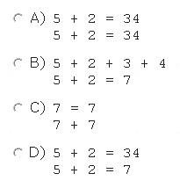

1. Option A
2. Option B
3. Option C
4. Option D

## Answer: D

100. Given:

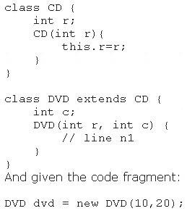

Which code fragment should you use at line n1 to instantiate the dvd object successfully?

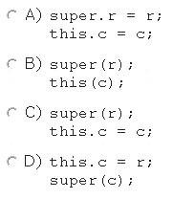

1. Option A
2. Option B
3. Option C
4. Option D

## Answer: C

101. Given the code fragment:

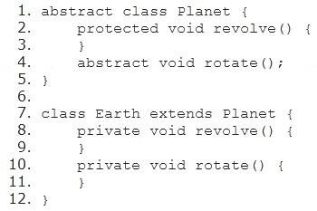

Which two modifications enable the code to compile? A. Make the method at line 8 protected.

1. Make the method at line 8 public.
2. Make the method at line 10 protected.
3. Make the method at line 4 public.
4. Make the method at line 2 public.

**Answer:** AC yada BC cikti

102. Given the code fragment:

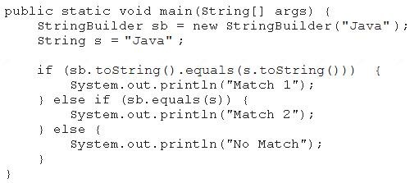

What is the result?

1. Match 1
2. Match 2
3. No Match
4. A NullPointerException is thrown at runtime.

## Answer: A

103. Given:

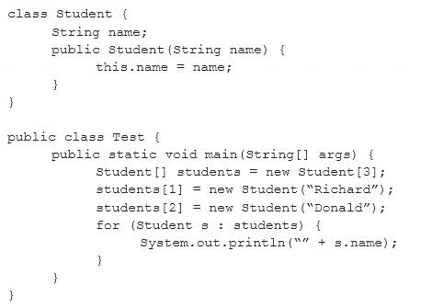

What is the result?

1. nullRichardDonald
2. RichardDonald
3. Compilation fails.
4. An ArrayIndexOutOfBoundsException is thrown at runtime.
5. A NullPointerException is thrown at runtime.

## Answer: E

104. Given the code fragment:

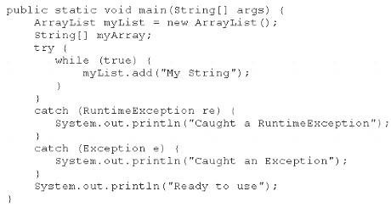

What is the result?

1. Execution terminates in the first catch statement, and Caught a RuntimeException is printed to the console.
2. Execution terminates in the second catch statement, and Caught an Exception is printed to the console.
3. A runtime error is thrown in the thread "main".
4. Execution completes normally, and Ready to use is printed to the console.
5. The code fails to compile because a throws keyword is required.

## Answer: C

105. Given:

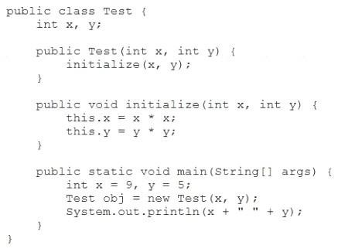

What is the result?

1. 9 5
2. 81 25
3. Compilation fails.
4. 0 0

## Answer: A

Explanation:

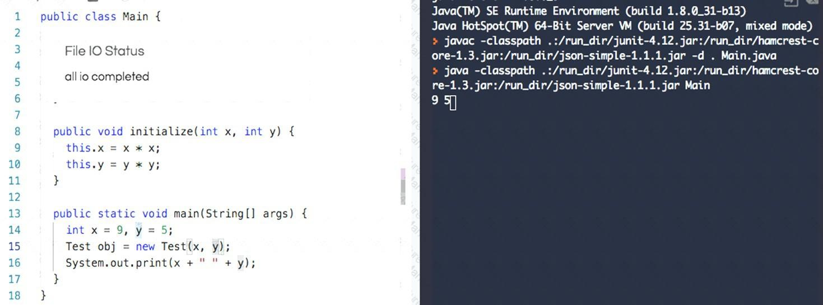

106. Given:

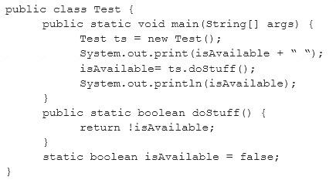

What is the result?

1. Compilation fails.
2. false true
3. true false
4. true true
5. false false

## Answer: B

107. Given:

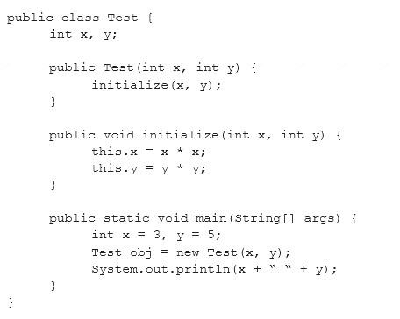

What is the result?

1. Compilation fails.
2. 3 5
3. 0 0
4. 9 25

**Answer:** B

108. Given these classes:

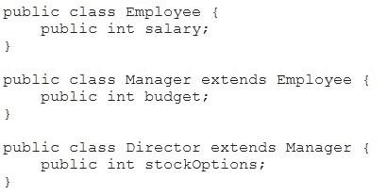

And given this main method:

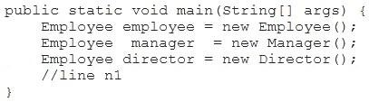

Which two options compile when placed at line n1 of the main method? (Choose two.)

1. director.stockOptions = 1_000;
2. employee.salary = 50_000;
3. manager.budget = 1_000_000;
4. manager.stockOption = 500;
5. employee.budget = 200_000;
6. director.salary = 80_000;

**Answer:** BF cikti

109. Given:

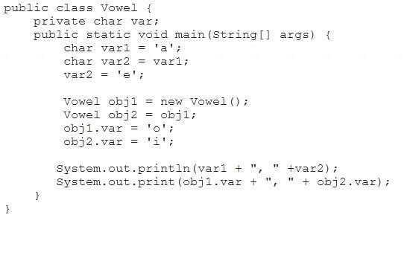

What is the result?

1. a, ei, i
2. a, eo, o
3. e, ei, i
4. a, ao, o

## Answer: A cikti

110. Given:

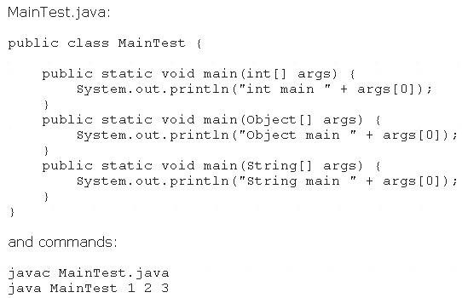

What is the result?

1. int main 1
2. Object main 1
3. String main 1
4. Compilation fails
5. An exception is thrown at runtime

## Answer: C

111. Given the code fragment:

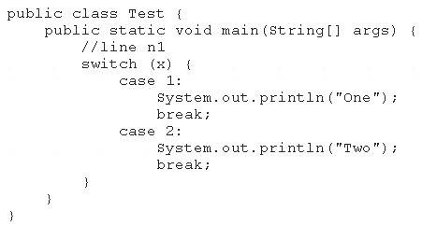

Which three code fragments can be independently inserted at line n1 to enable the code to print One?

(Choose three.)

1. byte x = 1;
2. short x = 1;
3. String x = "1";
4. long x = 1;
5. double x = 1;
6. Integer x = new Integer("1");

## Answer: ABF cikti

112. What is the name of the Java concept that uses access modifiers to protect variables and hide them within a class?

1. Encapsulation
2. Inheritance
3. Abstraction
4. Instantiation
5. Polymorphism

## Answer: A

Explanation:

Using the private modifier is the main way that an object encapsulates itself and hide data from the outside world.

113. Given the code fragment:

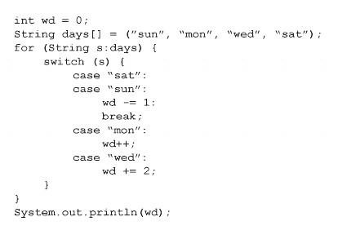

What is the result?

1. 3
2. 4
3. -1
4. Compilation fails.

## Answer: A

114. Given:

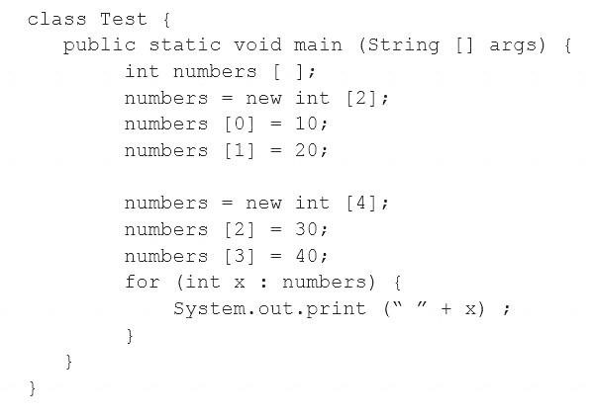

What is the result?

1. 10 20 30 40
2. 0 0 30 40
3. Compilation fails.
4. An exception is thrown at runtime.

**Answer:** B

115. Given:

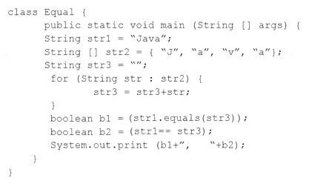

What is the result?

1. false, false
2. false, true
3. true, false
4. true, true

## Answer: C

116. Given the code fragment:

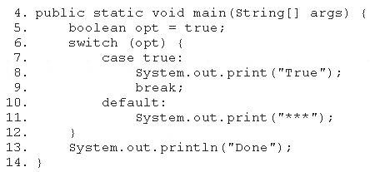

Which modification enables the code fragment to print TrueDone?

1. Replace line 5 With String opt = "true";Replace line 7 with case "true":
2. Replace line 5 with boolean opt = l;Replace line 7 with case 1:
3. At line 9, remove the break statement.
4. Remove the default section.

## Answer: A

117. Given the following class declarations:

* public abstract class Animal

 public interface Hunter

 public class Cat extends Animal implements Hunter

 public class Tiger extends Cat

Which answer fails to compile?

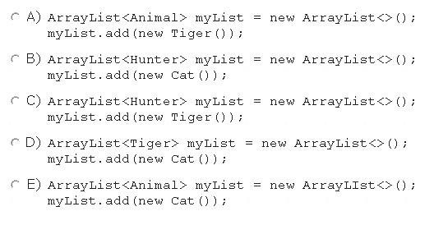

1. Option A
2. Option B
3. Option C
4. Option D
5. Option E

## Answer: D

118. Which two code fragments cause a compilation error? (Choose two.)

1. float flt = 100.00F;
2. float flt = (float) 1_11.00;
3. Float flt = 100.00;
4. double y1 = 203.22;

float flt = y1;

1. int y2 = 100;

float flt = (float) y2 ;

**Answer: C**Dcikti

119. Given:

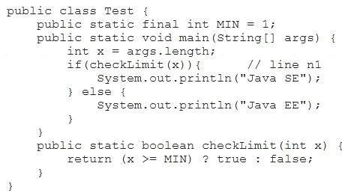

And given the commands:



What is the result?

1. Java SE
2. Java EE
3. Compilation fails at line n1.
4. A NullPointerException is thrown at runtime.

## Answer:A cikti

120. Given:

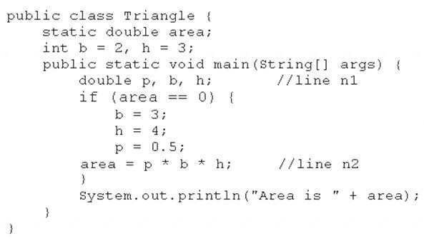

What is the result?

1. Area is 6.0
2. Area is 3.0
3. Compilation fails at line n1
4. Compilation fails at line n2.

**Answer:** A

121. Given the code fragment:

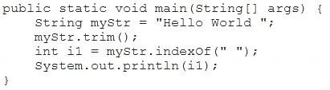

What is the result?

1. An exception is thrown at runtime.
2. -1
3. 5
4. 10

**Answer: C**

122. Given the code fragment:

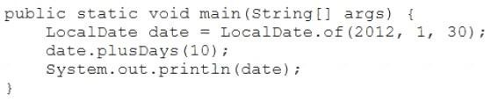

What is the result?

1. 2012-02-10
2. 2012-01-30
3. 2012-02-10 00:00
4. A DateTimeException is thrown at runtime.

## Answer: B

123. Given:

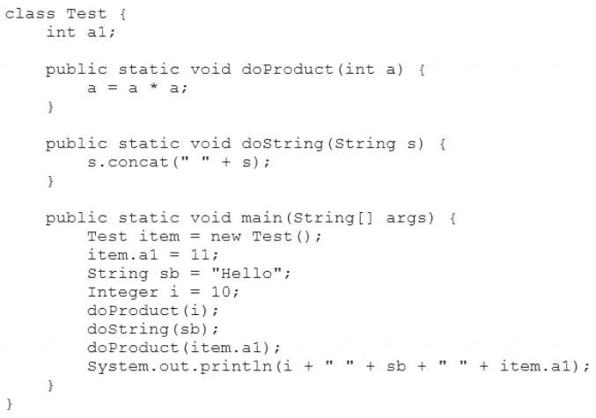

What is the result?

1. 10 Hello Hello 11
2. 10 Hello Hello 121
3. 100 Hello 121
4. 100 Hello Hello 121
5. 10 Hello 11

## Answer: E

124. Given the code snippet from a compiled Java source file:

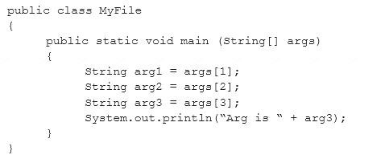

Which command-line arguments should you pass to the program to obtain the following output? Arg is 2

1. java MyFile 1 3 2 2
2. java MyFile 2 2 2
3. java MyFile 1 2 2 3 4
4. java MyFile 0 1 2 3

## Answer: A

125. Given:

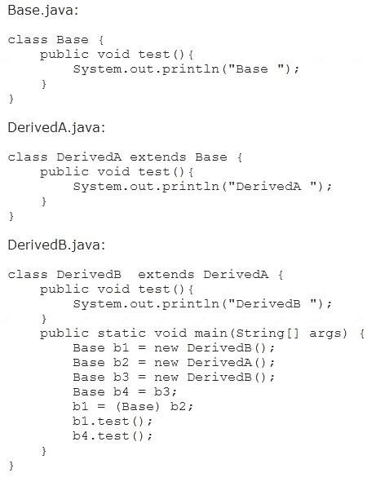

What is the result?

1. BaseDerivedA
2. BaseDerivedB
3. DerivedADerivedB
4. DerivedBDerivedA
5. A ClassCastException is thrown at runtime.

## Answer: C cikti

126. Given the code fragment:

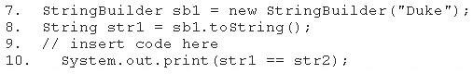

Which code fragment, when inserted at line 9, enables the code to print true?

1. String str2 = str1;
2. String str2 = new String(str1);
3. String str2 = sb1. toString();
4. String str2 = "Duke";

## Answer: A

127. Given this class:

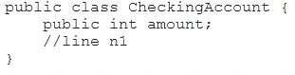

And given this main method, located in another class:

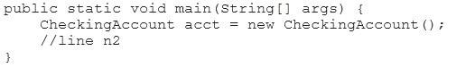

Which three pieces of code, when inserted independently, set the value of amount to 100?

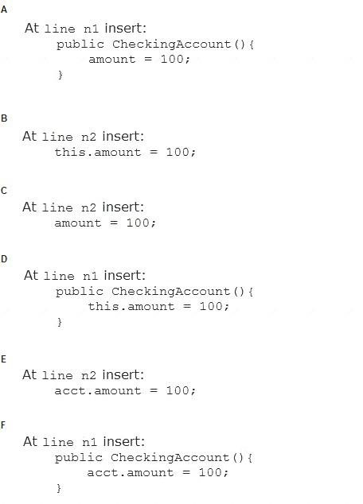

1. Option A
2. Option B
3. Option C
4. Option D
5. Option E
6. Option F

**Answer: A**DE cikti

128. Given:

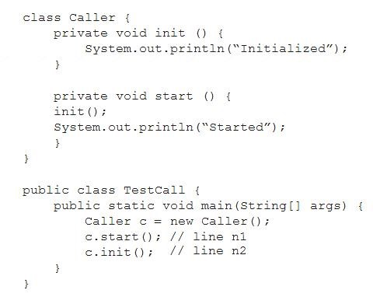

What is the result?

1. Compilation fails at line n1.
2. InitializedStartedInitialized
3. InitializedStarted
4. Compilation fails at line n1 and n2.

## Answer: D

129. Given:

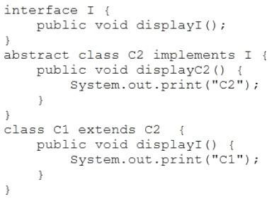

And the code fragment:

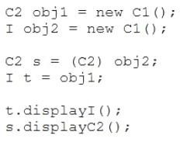

What is the result?

1. C1C2
2. C1C1
3. Compilation fails.
4. C2C2

## Answer: A

Explanation:

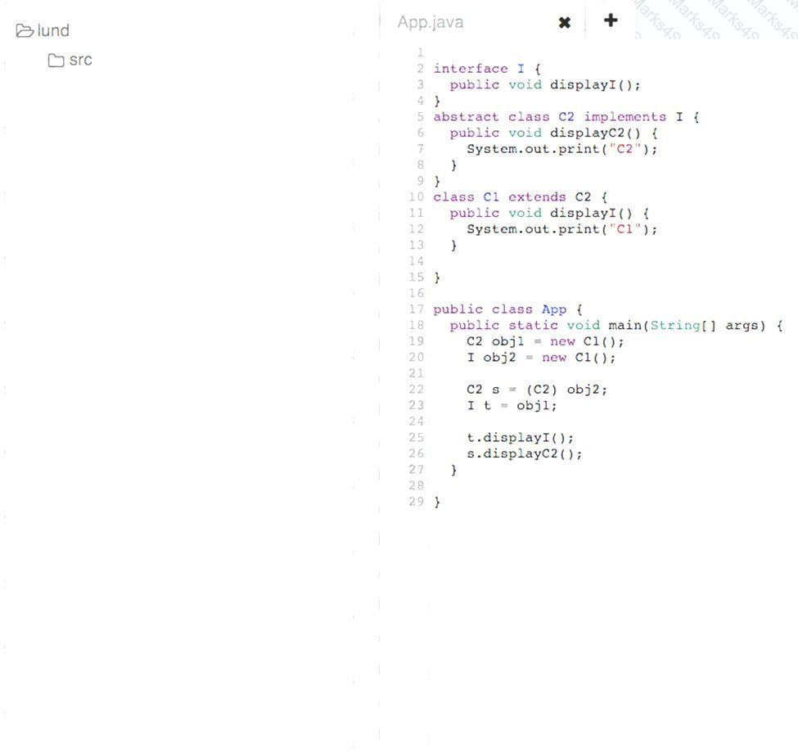

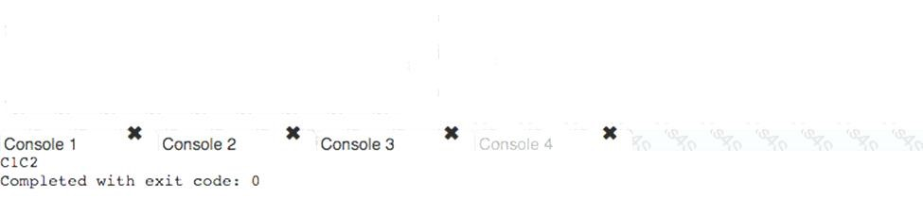

130. Given the code fragment:

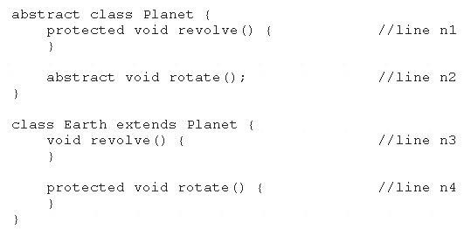

Which two modifications, made independently, enable the code to compile? (Choose two.) A. Make the method at line n1 public.

1. Make the method at line n2 public.
2. Make the method at line n3 public.
3. Make the method at line n3 protected.
4. Make the method at line n4 public.

## Answer: CD

131. Given the code fragment:

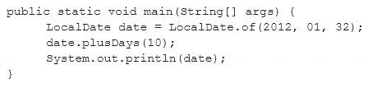

What is the result?

1. 2012-02-10
2. 2012-02-11
3. Compilation fails
4. A DateTimeException is thrown at runtime.

## Answer: D

132. Given:

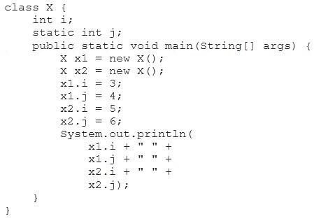

What is the result?

1. 3 4 5 6
2. 3 4 3 6
3. 5 4 5 6
4. 3 6 5 6

## Answer: D

Explanation:



133. Which statement is true about Java byte code? A. It can run on any platform.

1. It can run on any platform only if it was compiled for that platform.
2. It can run on any platform that has the Java Runtime Environment.
3. It can run on any platform that has a Java compiler.
4. It can run on any platform only if that platform has both the Java Runtime Environment and a Java

compiler.

## Answer: C cikti

Explanation:

Java bytecodes help make "write once, run anywhere" possible. You can compile your program into bytecodes on any platform that has a Java compiler. The bytecodes can then be run on any implementation of the Java VM. That means that as long as a computer has a Java VM, the same program written in the Java programming language can run on Windows 2000, a Solaris workstation, or on an iMac.

134. Which is true about the switch statement?

1. Its expression can evaluate to a collection of values.
2. The break statement, at the end of each case block, is optional.
3. Its case label literals can be changed at runtime.
4. It must contain the default section.

## Answer: B

135. Given the code fragment:

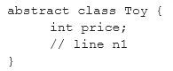

Which three code fragments are valid at line n1?

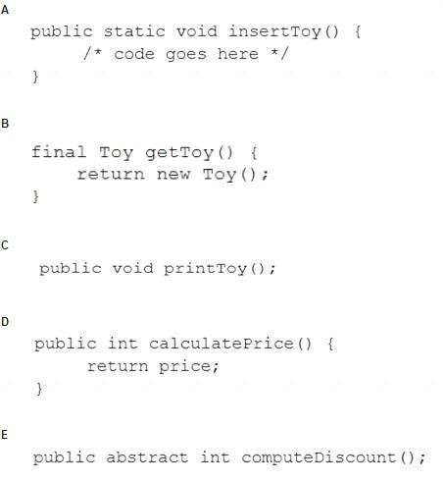

1. Option A
2. Option B
3. Option C
4. Option D
5. Option E

**Answer:** ADE cikti

136. Given:

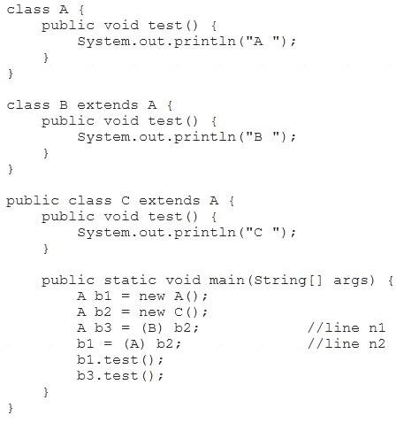

What is the result?

1. AB
2. AC
3. CC
4. A ClassCastException is thrown only at line n1.
5. A ClassCastException is thrown only at line n2.

## Answer: D cikti

137. Which three statements are true about exception handling? (Choose three.) A. Only unchecked exceptions can be rethrown.

1. All subclasses of the RuntimeException class are not recoverable.
2. The parameter in a catch block is of Throwable type.
3. All subclasses of the RuntimeException class must be caught or declared to be thrown.
4. All subclasses of the RuntimeException class are unchecked exceptions.
5. All subclasses of the Error class are not recoverable.

**Answer:** BCD cikti biz CEF

138. Given the code fragment:

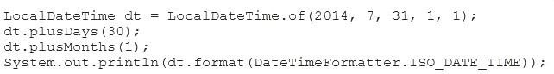

What is the result?

1. An exception is thrown at runtime.
2. 2014-07-31T01:01:00
3. C. 2014-07-31

D. 2014-09-30T00:00:00

## Answer: B cikti

139. Given:

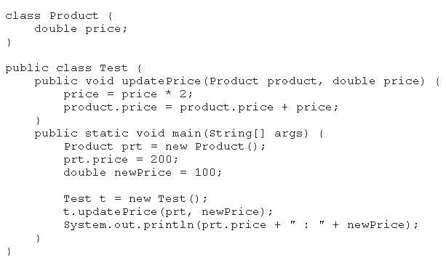

What is the result?

1. 200.0 : 100.0
2. 400.0 : 200.0
3. 400.0 : 100.0
4. Compilation fails.

## Answer: C

140. Given:

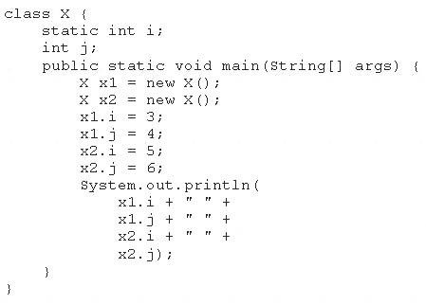

What is the result?

1. 3 4 5 6
2. 3 4 3 6
3. 5 4 5 6
4. 3 6 4 6

## Answer: C

141. Given the code fragment:

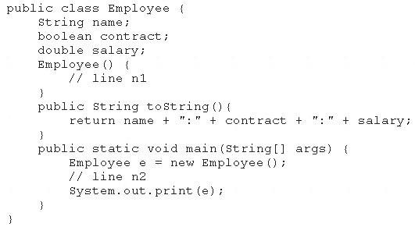

Which two modifications, when made independently, enable the code to print Joe:true: 100.0? (Choose

two.)

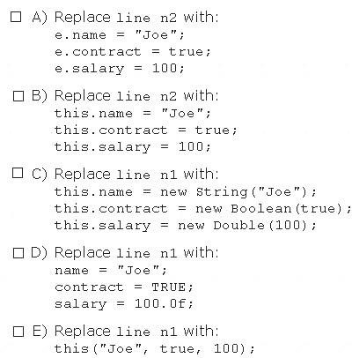

1. Option A
2. Option B
3. Option C
4. Option D
5. Option E

**Answer:** AC cikti

142. Given:

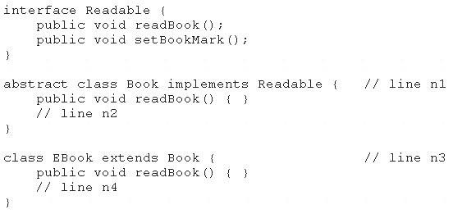

And given the code fragment: Book book1 = new EBook(); book1.readBook(); Which option enables the code to compile?

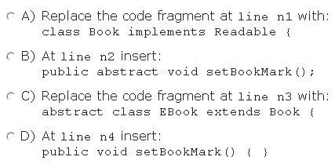

1. Option A
2. Option B
3. Option C
4. Option D

## Answer: D

143. Given:

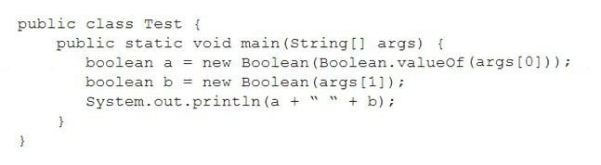

And given the commands:



What is the result?

1. 1 null
2. true false
3. false false
4. true true
5. A ClassCastException is thrown at runtime.

## Answer:C

144. Given:

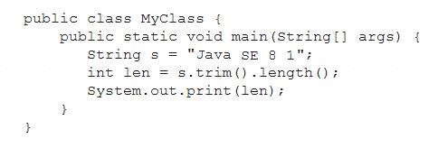

What is the result?

1. Compilation fails.
2. 11
3. 8
4. 9
5. 10

## Answer: B

145. Given:

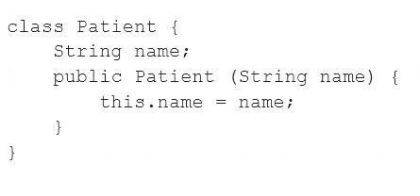

And the code fragment:

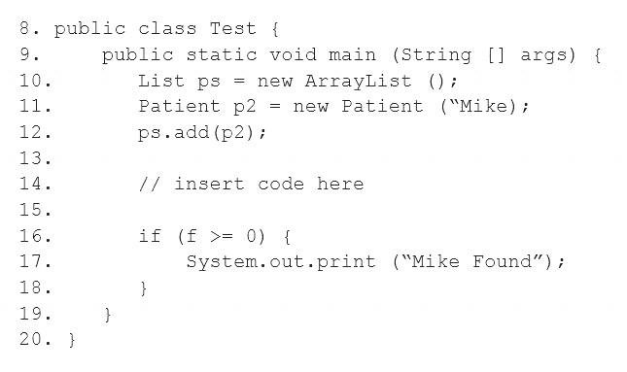

Which code fragment, when inserted at line 14, enables the code to print Mike Found?

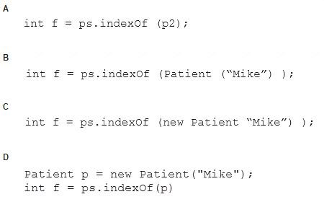

1. Option A
2. Option B
3. Option C
4. Option D

**Answer:** A

146. Given the code fragment:

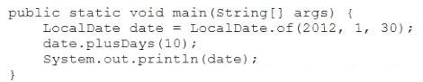

What is the result?

1. 2012-02-10 00:00
2. 2012-01-30   
   C. 2012-02-10

D. A DateTimeException is thrown at runtime.

## Answer: B

Explanation:

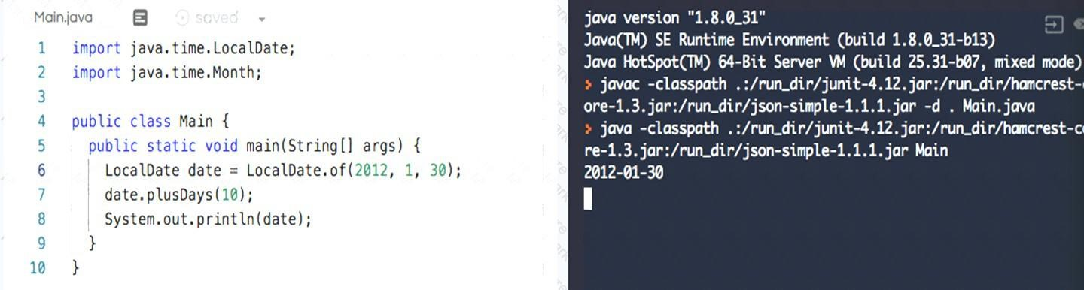

147. Given:

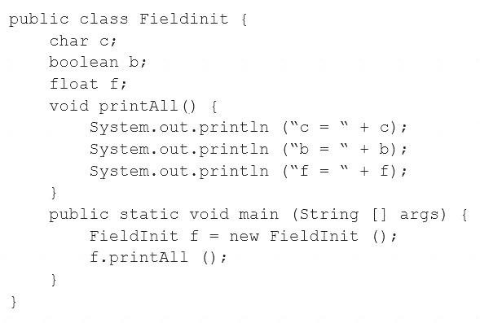

What is the result?

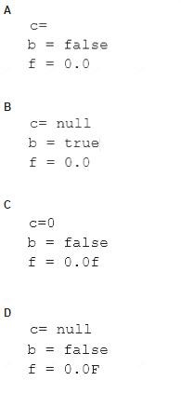

1. Option A
2. Option B
3. Option C
4. Option D

## Answer: A

148. This grid shows the state of a 2D array:

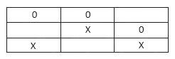

The grid is created with this code:

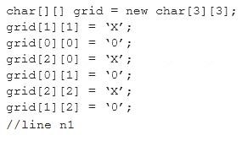

Which line of code, when inserted in place of //line n1, adds an X into the grid so that the grid contains three consecutive Xs?

1. grid[2][1] = ‘X’;
2. grid[3][2] = ‘X’;
3. grid[3][1] = ‘X’;
4. grid[2][3] = ‘X’;

## Answer: A

149. Which two statements are true about Java byte code? (Choose two.) A. It can be serialized across network.

1. It can run on any platform that has a Java compiler.
2. It can run on any platform.
3. It has “.java” extension.
4. It can run on any platform that has the Java Runtime Environment.

## Answer: AE cikti

150. Given the code from the Greeting.Java file:

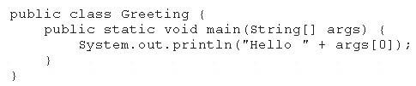

Which set of commands prints Hello Duke in the console?

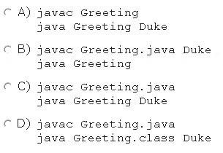

1. Option A
2. Option B
3. Option C
4. Option D

## Answer: C

151. Given these two classes:

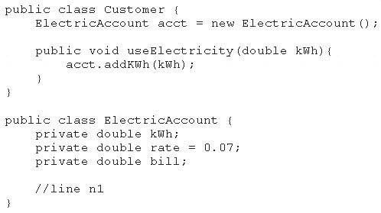

Any amount of electricity used by a customer (represented by an instance of the Customer class) must contribute to the customer's bill (represented by the member variable bill) through the useElectricity method.

An instance of the Customer class should never be able to tamper with or decrease the value of the member variable bill.

How should you write methods in the ElectricAccount class at line n1 so that the member variable bill is always equal to the value of the member variable kwh multiplied by the member variable rate?

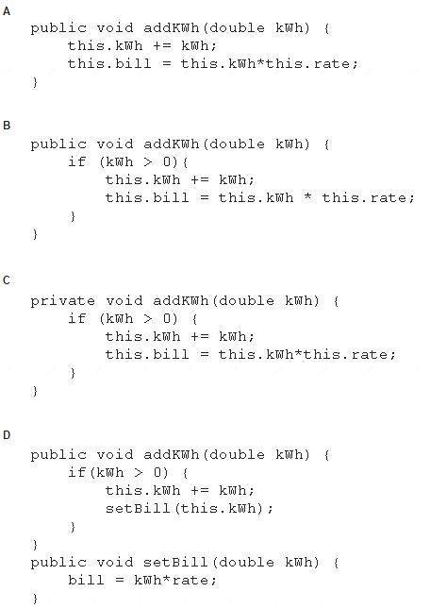

1. Option A
2. Option B
3. Option C
4. Option D

## Answer: B ve D ama B daha yuksek cikti canvasta cevap D

152. Given the code fragment:

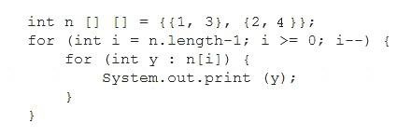

What is the result?

1. 1324
2. 2313
3. 3142
4. 2413

## Answer: D

153. Given the code fragment:

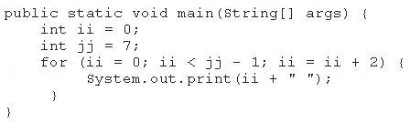

What is the result?

1. 2 4
2. 0 2 4 6
3. 0 2 4
4. Compilation fails

## Answer: C

154. Given:

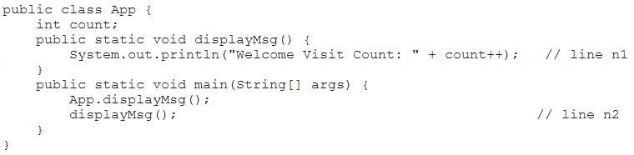

What is the result?

1. Welcome Visit Count:0Welcome Visit Count: 1
2. Compilation fails at line n2.
3. Compilation fails at line n1.
4. Welcome Visit Count:0Welcome Visit Count: 0

## Answer: C cikti

Explanation:

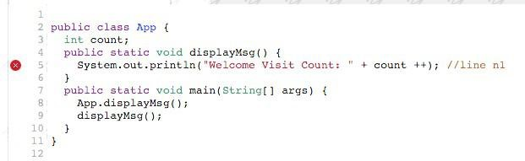

155. Given the code fragment:

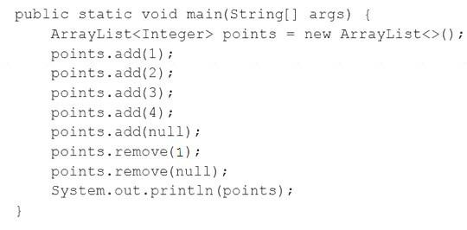

What is the result?

1. A NullPointerException is thrown at runtime.
2. [1, 2, 4]
3. [1, 2, 4, null]
4. [1, 3, 4, null]
5. [1, 3, 4]
6. Compilation fails.

## Answer: E cikti

156. Given:

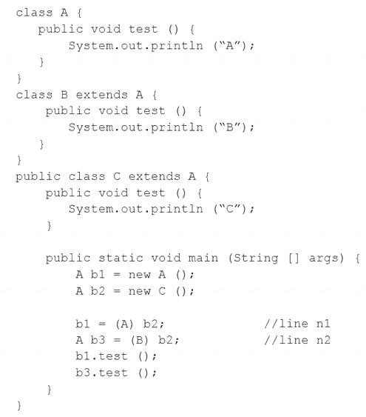

What is the result?

1. AB
2. AC
3. CC
4. A ClassCastException is thrown only at line n1.
5. A ClassCastException is thrown only at line n2.

## Answer: E cikti

157. Which two class definitions fail to compile? (Choose two.)

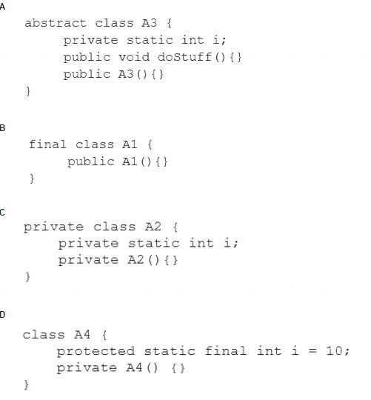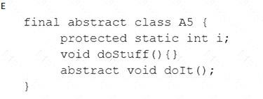

1. Option A
2. Option B
3. Option C
4. Option D
5. Option E

**Answer:** CE

158. Which statement is true about the switch statement?

A. It must contain the default section.

1. The break statement, at the end of each case block, is mandatory.
2. Its case label literals can be changed at runtime.
3. Its expression must evaluate to a single value.

## Answer: D

159. Given the code fragment:

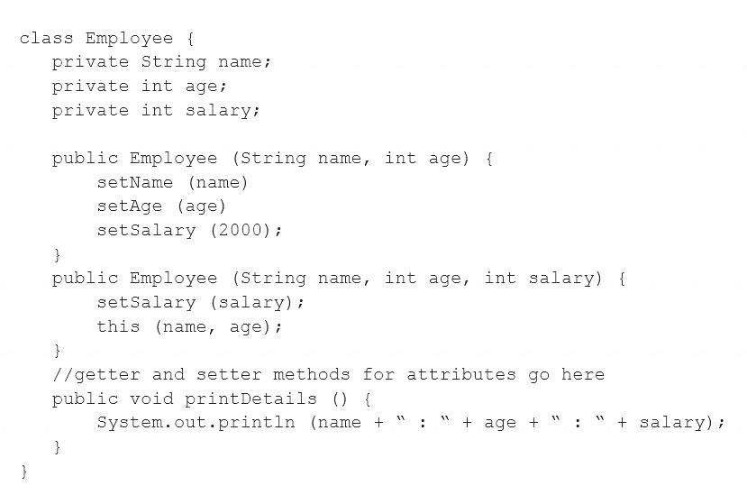

Test.java:



Which is the result?

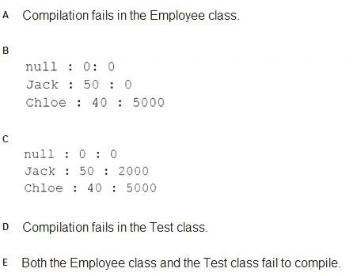

1. Option A
2. Option B
3. Option C
4. Option D E. Option E

## Answer: E

160. Given:

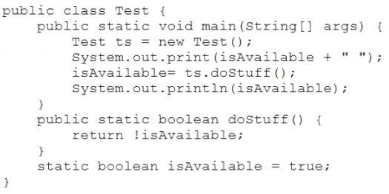

What is the result?

1. Compilation fails.
2. false true
3. true false
4. true true
5. false false

## Answer: C

Explanation:

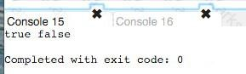

161. Which two are benefits of polymorphism? (Choose two.)

1. Faster code at runtime
2. More efficient code at runtime
3. More dynamic code at runtime
4. More flexible and reusable code

**E.** Code that is protected from extension by other classes

Answer: BDcikti

162. Given:

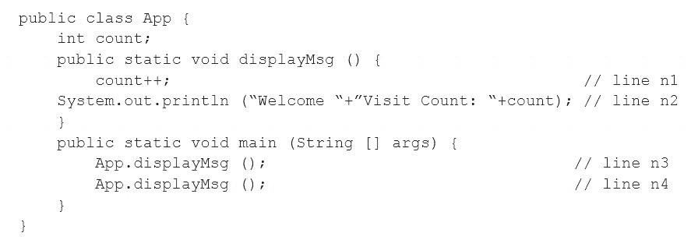

What is the result?

1. Compilation fails at line n3 and line n4.
2. Compilation fails at line n1 and line n2.
3. Welcome Visit Count:1Welcome Visit Count: 1
4. Welcome Visit Count:1Welcome Visit Count: 2

**Answer:** B

163. Given the code fragment:

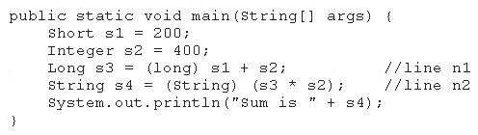

What is the result?

1. Sum is 600
2. Compilation fails at line n1.
3. Compilation fails at line n2.
4. A ClassCastException is thrown at line n1.
5. A ClassCastException is thrown at line n2.

## Answer: C

164. Given the code fragment:

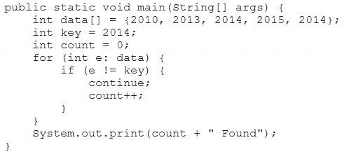

What is the result?

1. Compilation fails.
2. 0 Found
3. 1 Found
4. 3 Found

**Answer:** A cikti

165. Given the code fragment:

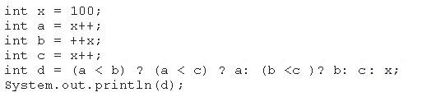

What is the result?

1. 100
2. 101
3. 102
4. 103
5. Compilation fails

## Answer: A cikti

166. Given this code for a Planet object:

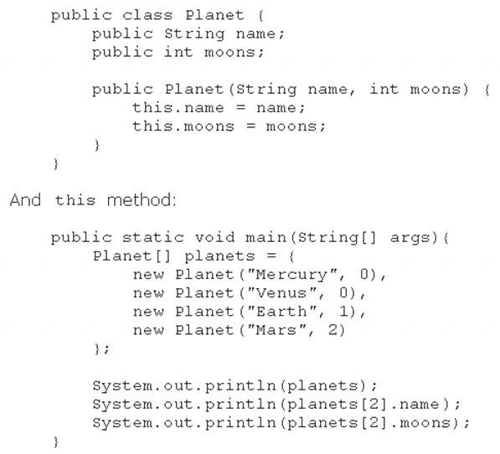

What is the output?

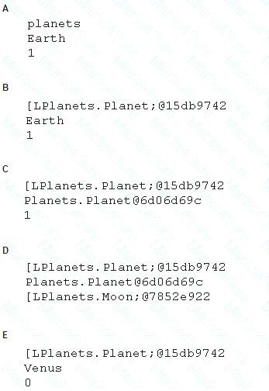

1. Option A
2. Option B
3. Option C
4. Option D E. Option E

## Answer: B

167. Given the code fragment:

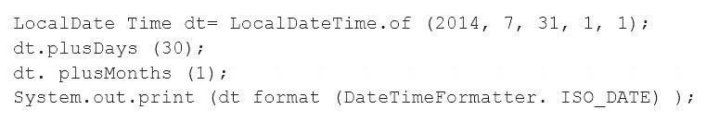

What is the result?

1. An exception is thrown at runtime.
2. 07-31-2014
3. 2014-07-31
4. 2014-09-30

## Answer: C cikti

168. Given the code fragment:

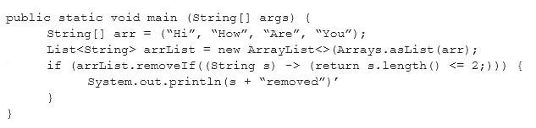

What is the result?

1. Compilation fails.
2. Hi removed
3. An UnsupportedOperationException is thrown at runtime.
4. The program compiles, but it prints nothing.

**Answer:** A 169. Given:

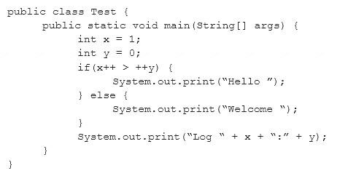

What is the result?

1. Hello Log 1:0
2. Hello Log 2:1
3. Welcome Log 2:1
4. Welcome Log 1:0

## Answer: C

170. Given the definitions of the MyString class and the Test class:

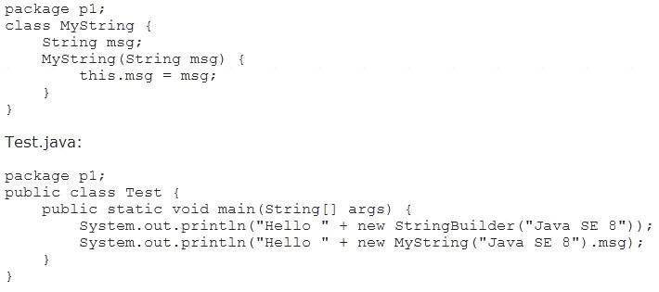

What is the result?

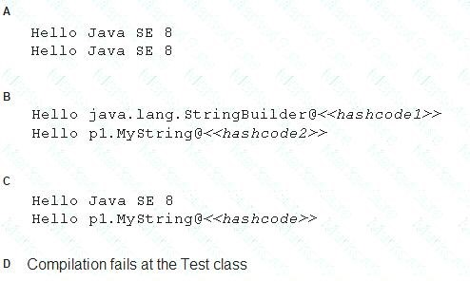

1. Option A
2. Option B
3. Option C
4. Option D
5. Option E

## Answer: A

171. Given:

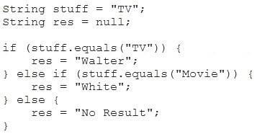

Which code fragment can replace the if block?

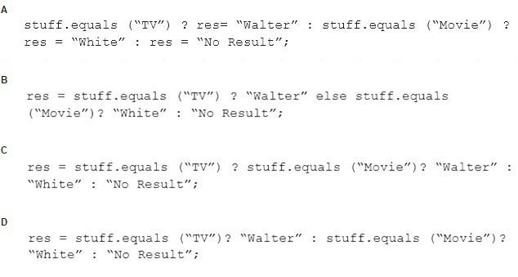

1. Option A
2. Option B
3. Option C
4. Option D

## Answer: D cikti

172. You are asked to develop a program for a shopping application, and you are given this information:

* The application must contain the classes Toy, EduToy, and ConsToy. The Toy class is the superclass

of the other two classes.

* The int calculatePrice (Toy t) method calculates the price of a toy.
* The void printToy (Toy t) method prints the details of a toy.

Which definition of the Toy class adds a valid layer of abstraction to the class hierarchy?

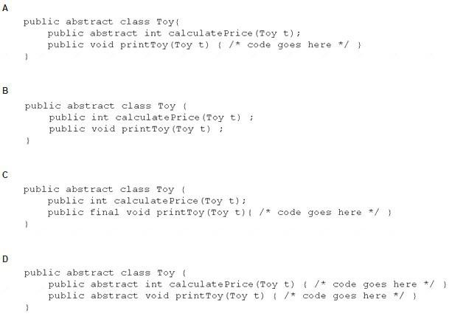

1. Option A
2. Option B
3. Option C
4. Option D

## Answer: A cikti

173. Given the following main method:

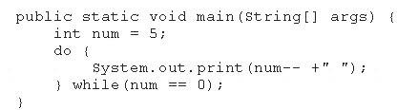

What is the result?

1. 5 4 3 2 1 0
2. 5 4 3 2 1
3. 4 2 1
4. 5
5. Nothing is printed

## Answer: D

174. Given the code fragments: 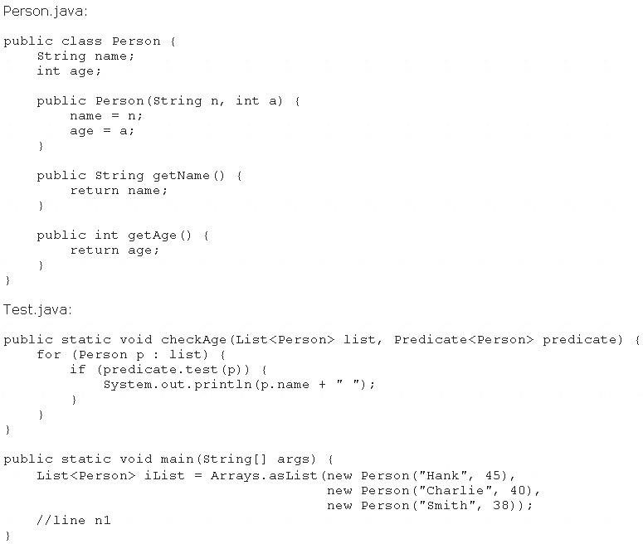

Which code fragment, when inserted at line n1, enables the code to print Hank?

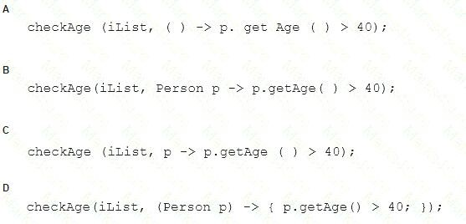

1. Option A
2. Option B
3. Option C
4. Option D

## Answer: C

175. Given the following classes:

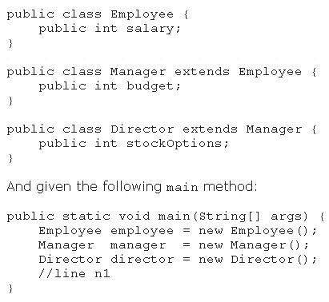

Which two options fail to compile when placed at line n1 of the main method? (Choose two.)

1. employee.salary = 50_000;
2. director.salary = 80_000;
3. employee.budget = 200_000;
4. manager.budget = 1_000_000;
5. manager.stockOption = 500;
6. director.stockOptions = 1_000;

## Answer: CE cikti

176. Given the code fragments:

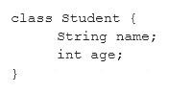

And:

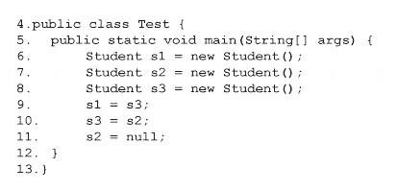

Which statement is true?

1. After line 11, three objects are eligible for garbage collection.
2. After line 11, two objects are eligible for garbage collection.
3. After line 11, one object is eligible for garbage collection.
4. After line 11, none of the objects are eligible for garbage collection.

## Answer: C citti

177. Given the content of three files:

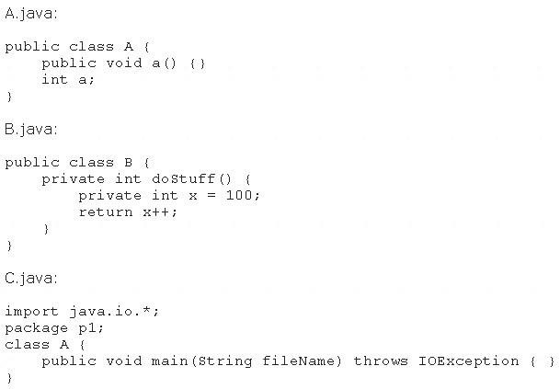

Which statement is true?

1. Only the A.Java file compiles successfully.
2. Only the B.java file compiles successfully.
3. Only the C.java file compiles successfully.
4. The A.Java and B.java files compile successfully.
5. The B.java and C.java files compile successfully.
6. The A.Java and C.java files compile successfully.

**Answer:** A

178. Given the code fragment:

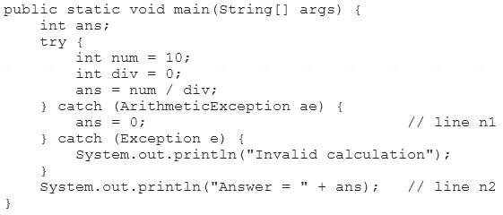

What is the result?

1. Answer = 0
2. Invalid calculation
3. Compilation fails only at line n1.
4. Compilation fails only at line n2.
5. Compilation fails at line n1 and line2.

## Answer: D

## Explanation:

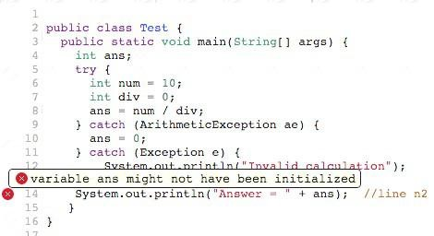

179. You are asked to create a method that accepts an array of integers and returns the highest value from

that array.

Given the code fragment:

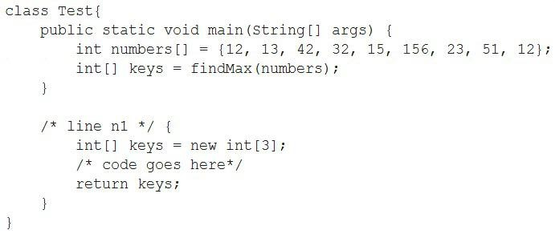

Which method signature do you use at line n1?

1. public int findMax (int[] numbers)
2. static int[] findMax (int[] max)
3. static int findMax (int[] numbers)
4. final int findMax (int[] )

## Answer: B cikti

180. Which one of the following code examples uses valid Java syntax?

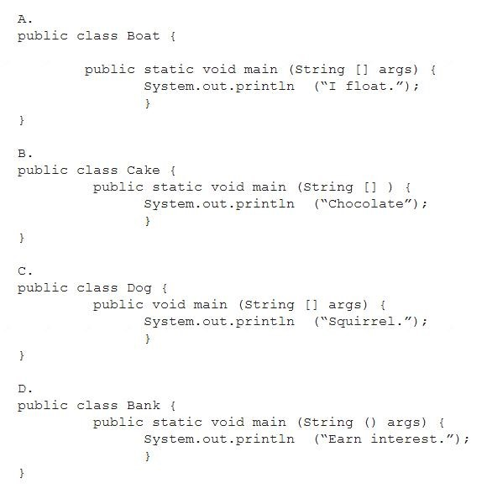

1. Option A
2. Option B
3. Option C
4. Option D

**Answer:** A

181. Given:

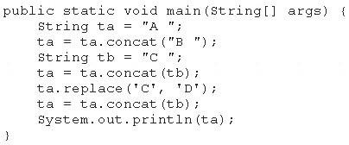

What is the result?

1. A B C C
2. A C D
3. A C D D
4. A B D
5. A B D C

## Answer: A